

**LAB-3**

**Freelancer Application using Spring Boot with JPA**

**CMPE-273**

**Enterprise Distributed System**

**Spring 2018**

**Student Id: 012560938**

**Student: Vaidehi Naik**

**Date of Submission:** **Submitted To:**

05/08/2018 Prof. Simon Shim

Table of Contents

Introduction: 3

Technology Stack: 3

System Design: 3

Client: 3

Server: 3

Architecture Diagram: 4

Snapshots: 4

Screenshot of Spring boot code: 15

Testing: 27

JMeter: 27

Junit: 32

Postman: 33

GitHub: 35

Github Link: 35

# Introduction:

We are developing a “Prototype of Freelancer Application” and the server is based on Spring boot. The server should be developed in a way, that it should perform the following tasks:

1. The basic functionalities of the users.
2. User can post the project.
3. The Home page
4. Details view in which there are all the details of project, all the bids list.
5. Dashboard

## Technology Stack:

We used the following technologies in this project:

* React
* Spring Boot
* Jmeter
* Junit
* Postman
* MySQL

# System Design:

## Client:

* Client side is developed in React which is javascript framework and for attractive UI, HTML,CSS and Bootstrap is used.
* As per the users requirement, it interacts with users and http requests.

## Server:

* Server is developed by using Spring Boot.
* The Freelancer application server handles the request sent by the client.
* As spring boot has Crud Repository and object oriented nature, it increases the development time rapidly.
* Whenever the client make any request, that request is handled by the spring boot server, it fetches the data from Mysql and give to the client.

## Architecture Diagram:

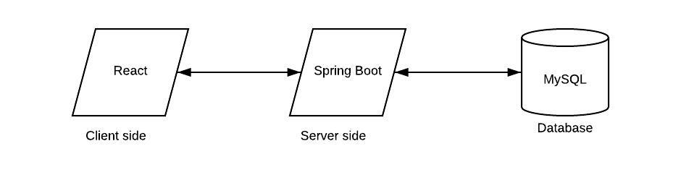

Figure 1: Architecture Diagram

# Snapshots:

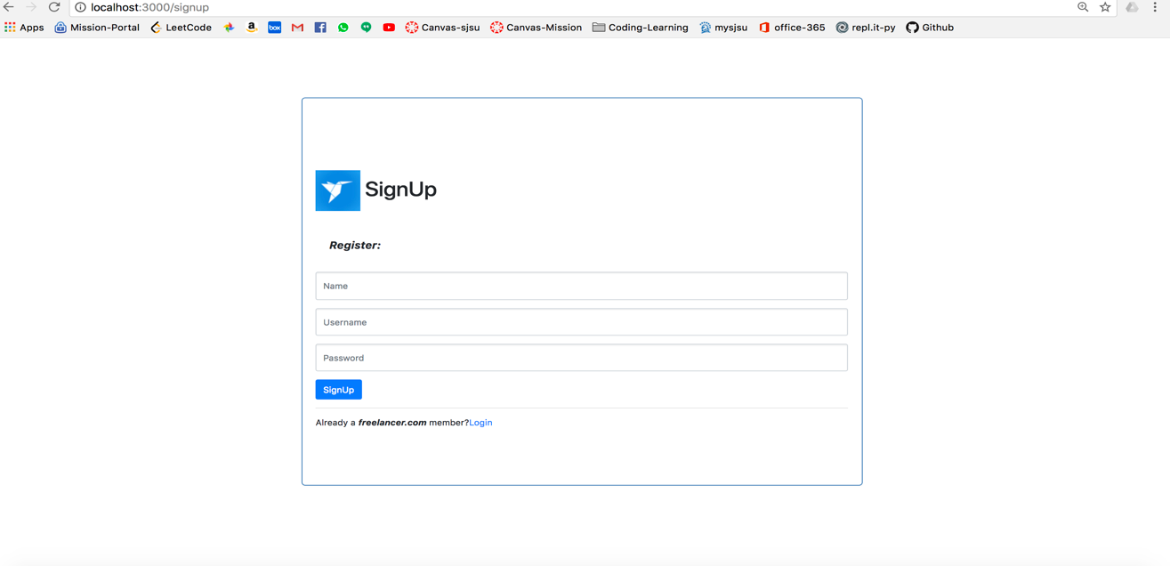

Figure 2: Signup page

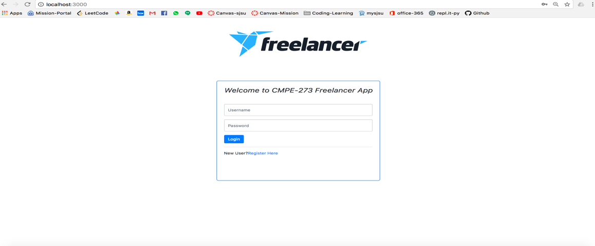

Figure 3: login page

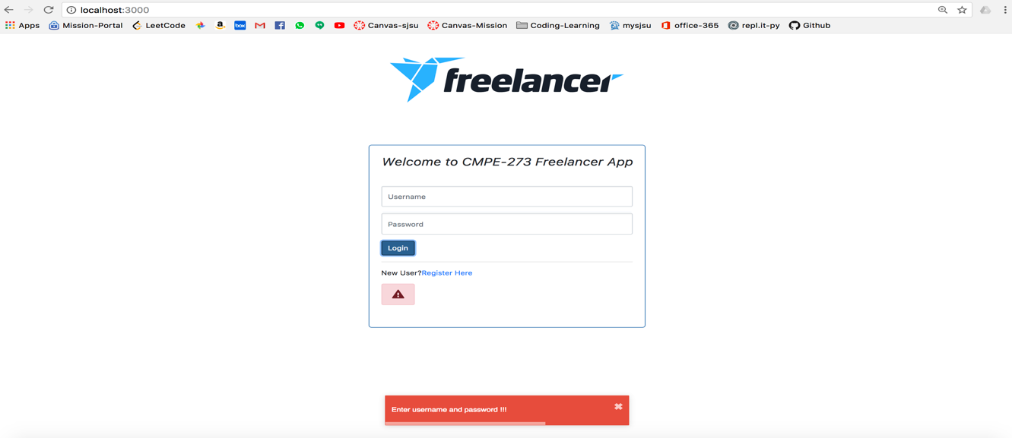

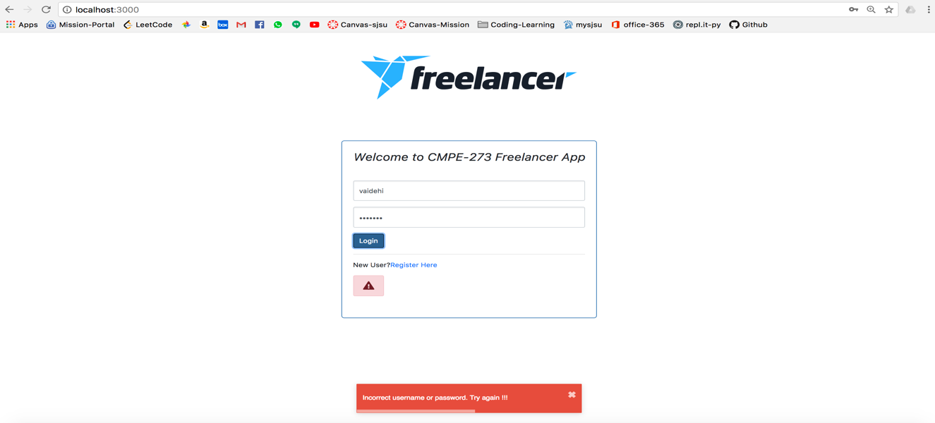

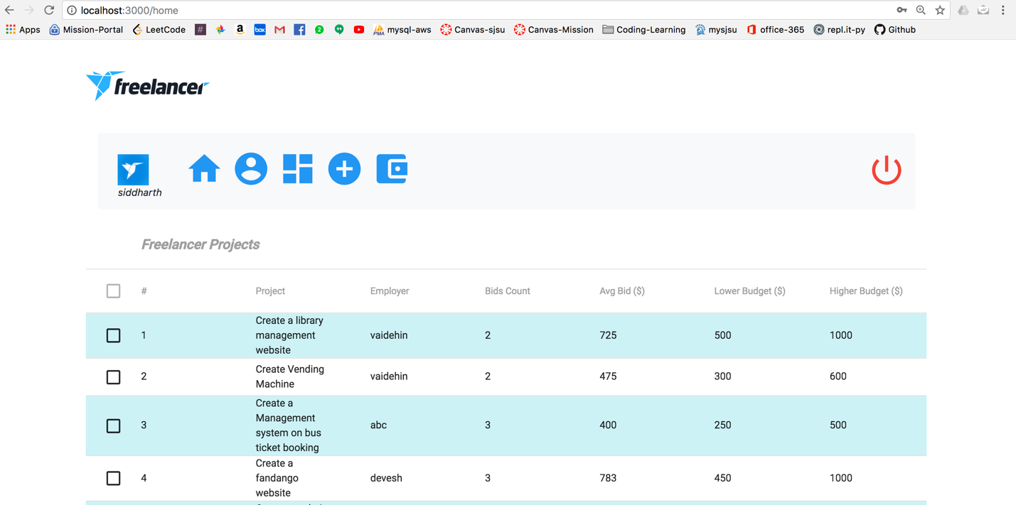

Figure 4: Home Page

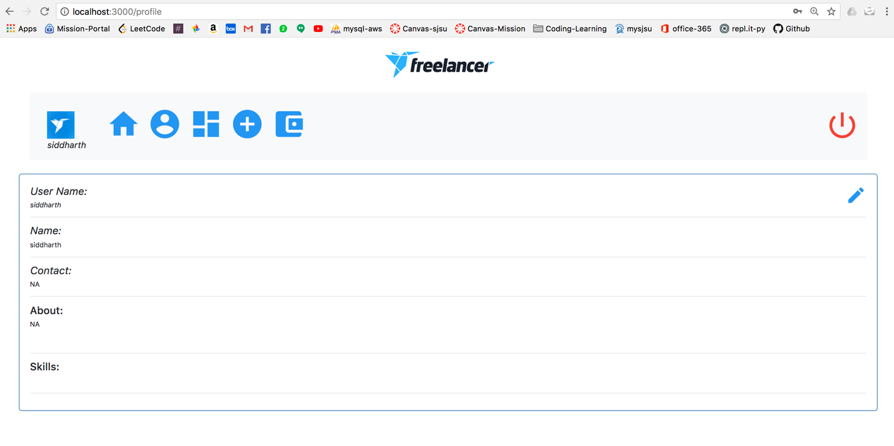

Figure 5: Profile page

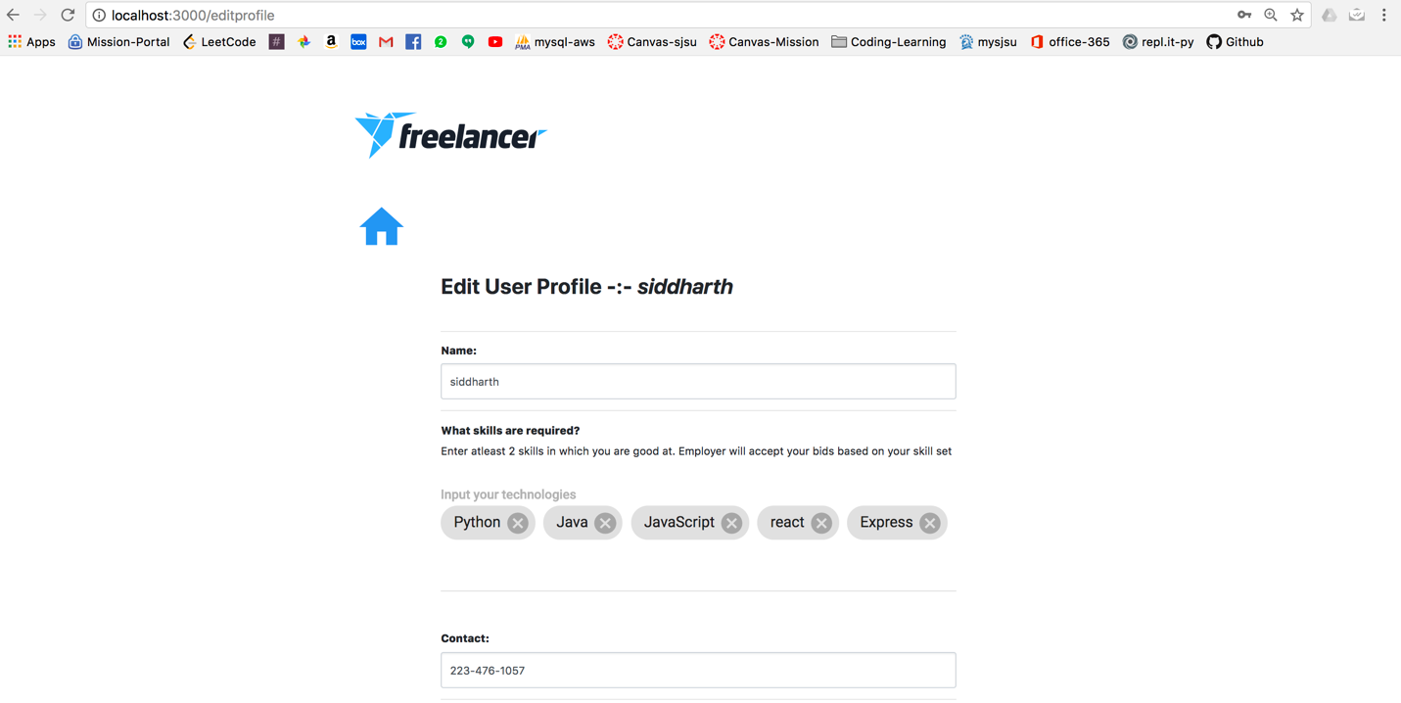

Figure 6: Edit Profile page Image 1

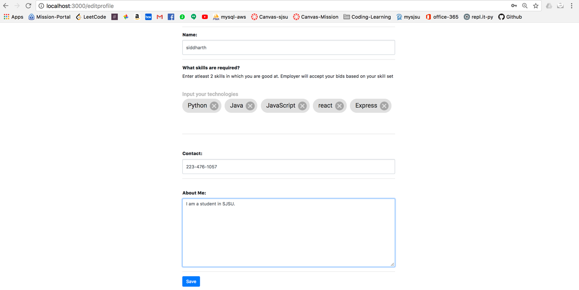

Figure 7: Edit Profile Page Image 2

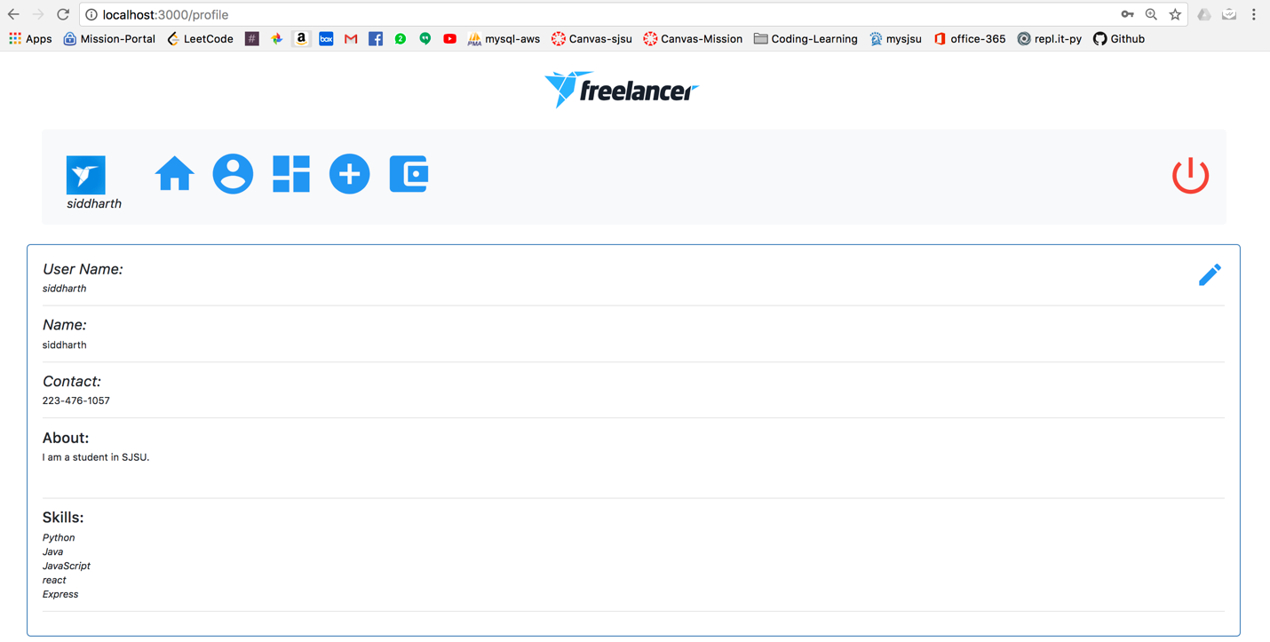

Figure 8: Profile page updated

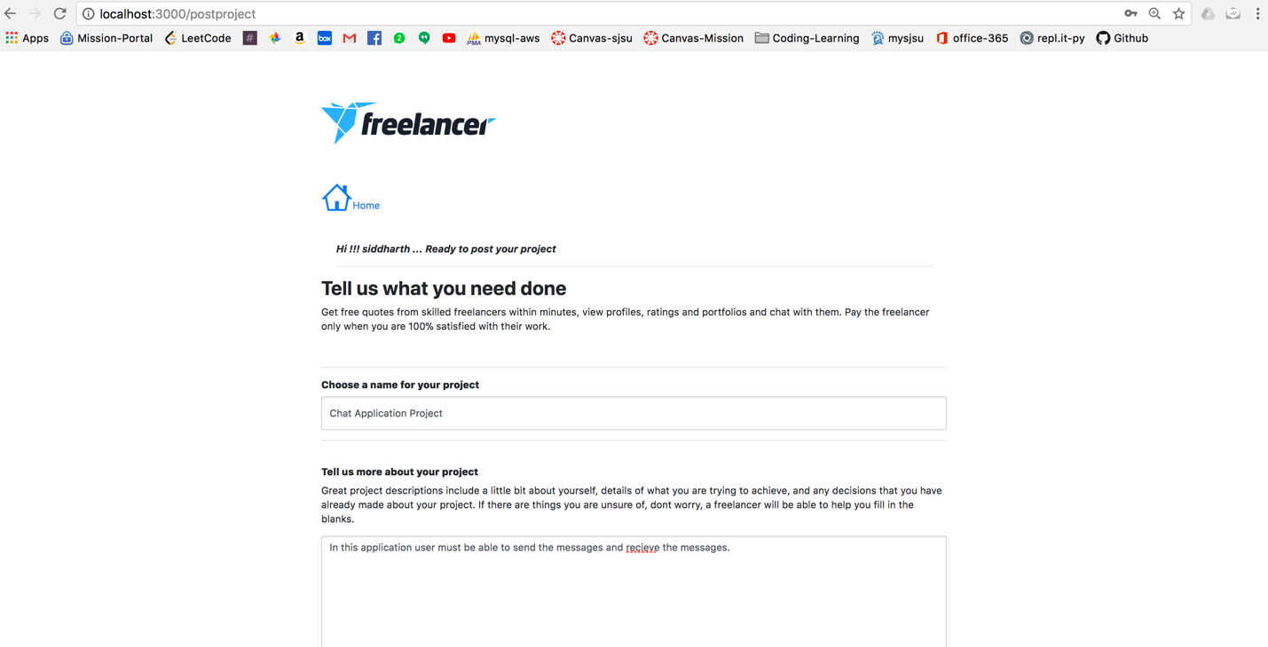

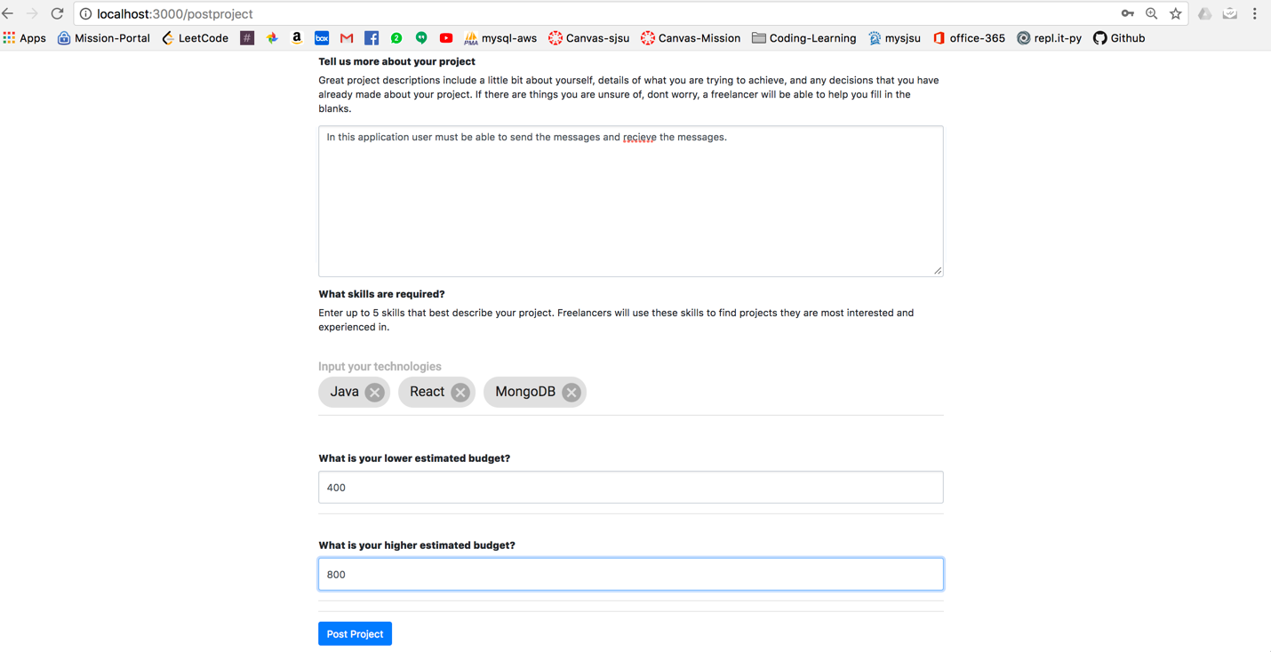

Figure 9: Post Project

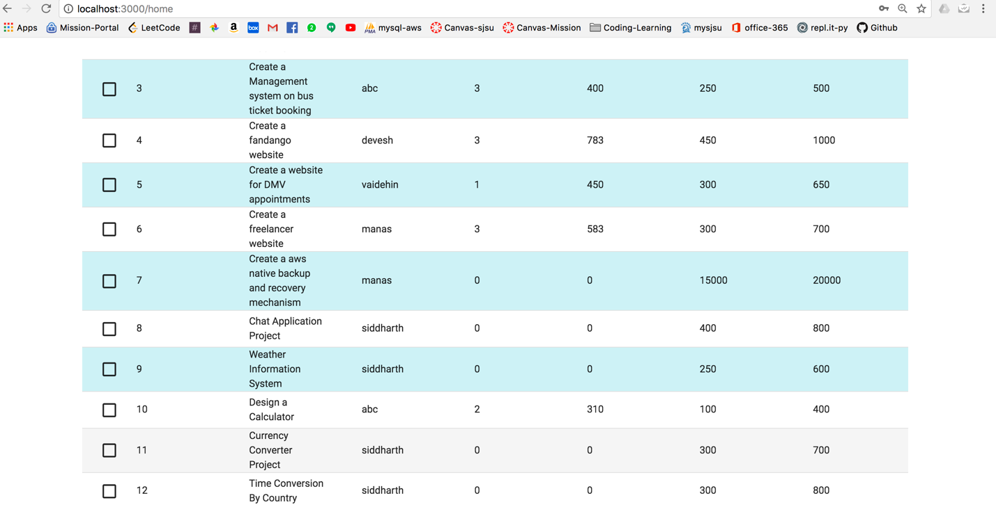

Figure 10: project is posted and updated on dashboard

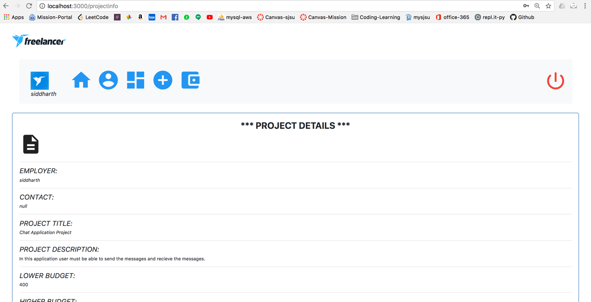

Figure 11: Project Details

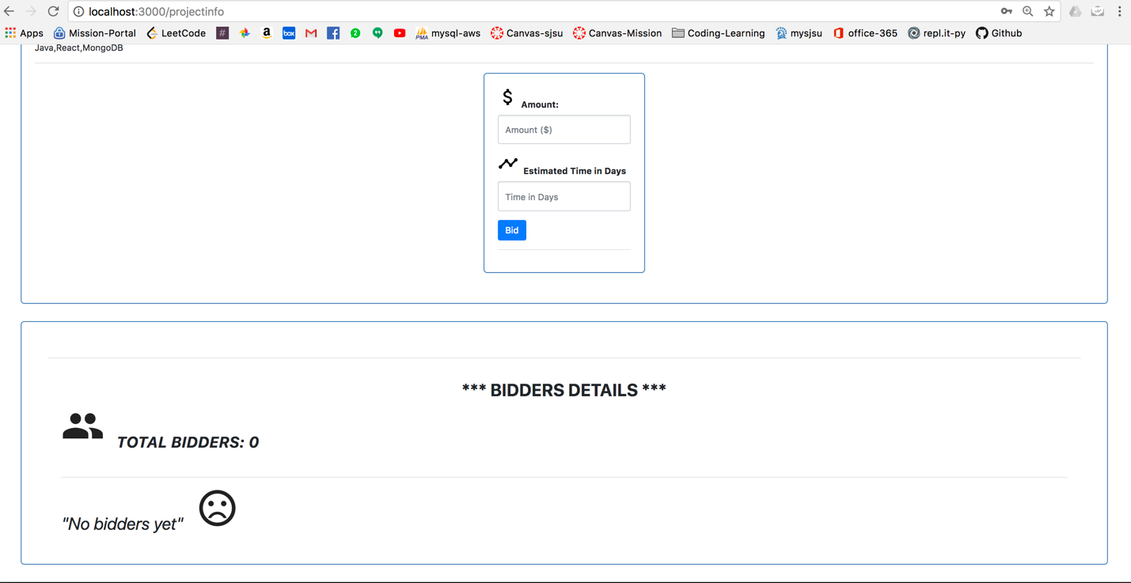

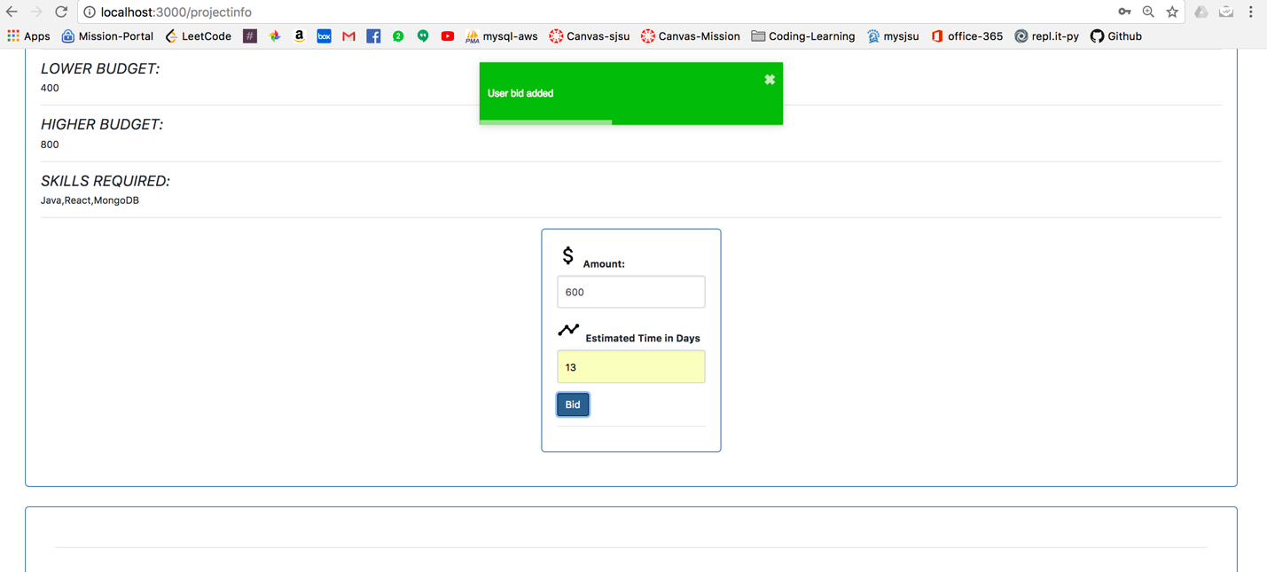

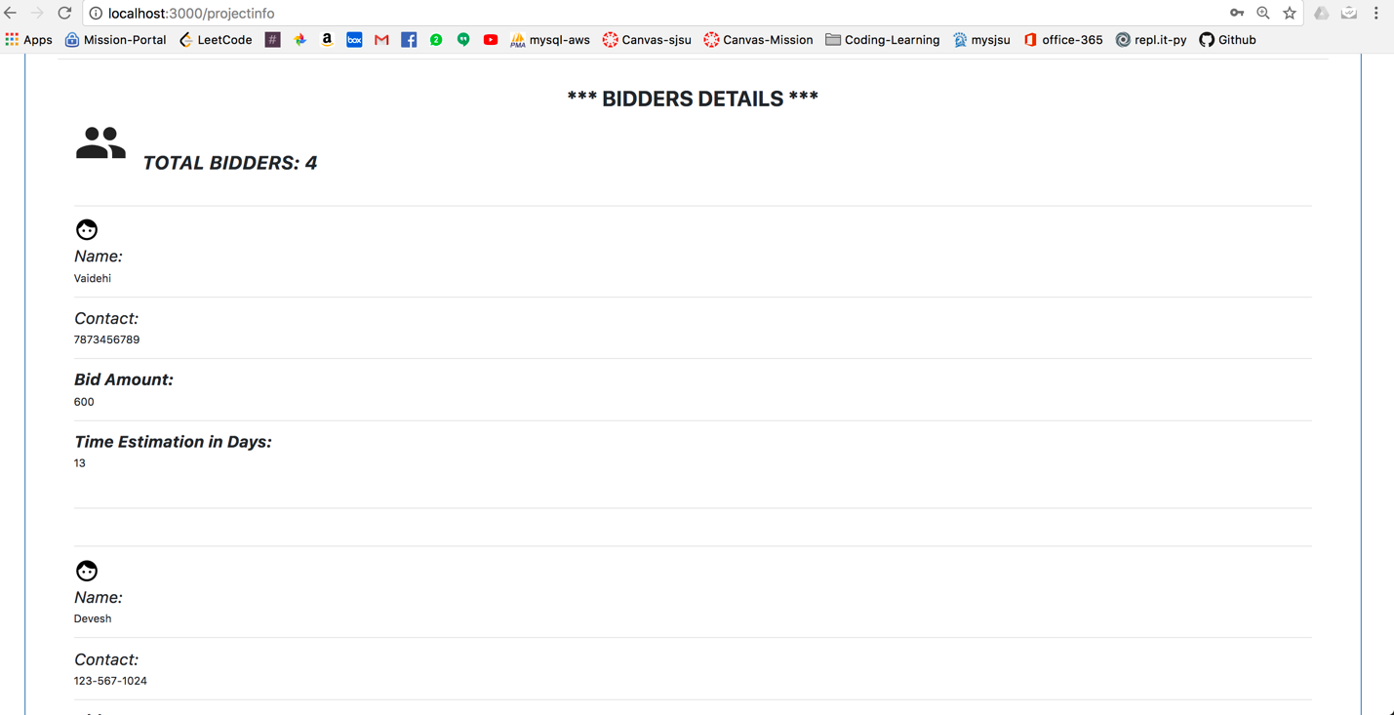

Figure 12: Bidder Details



Figure 13: Employer has logged in

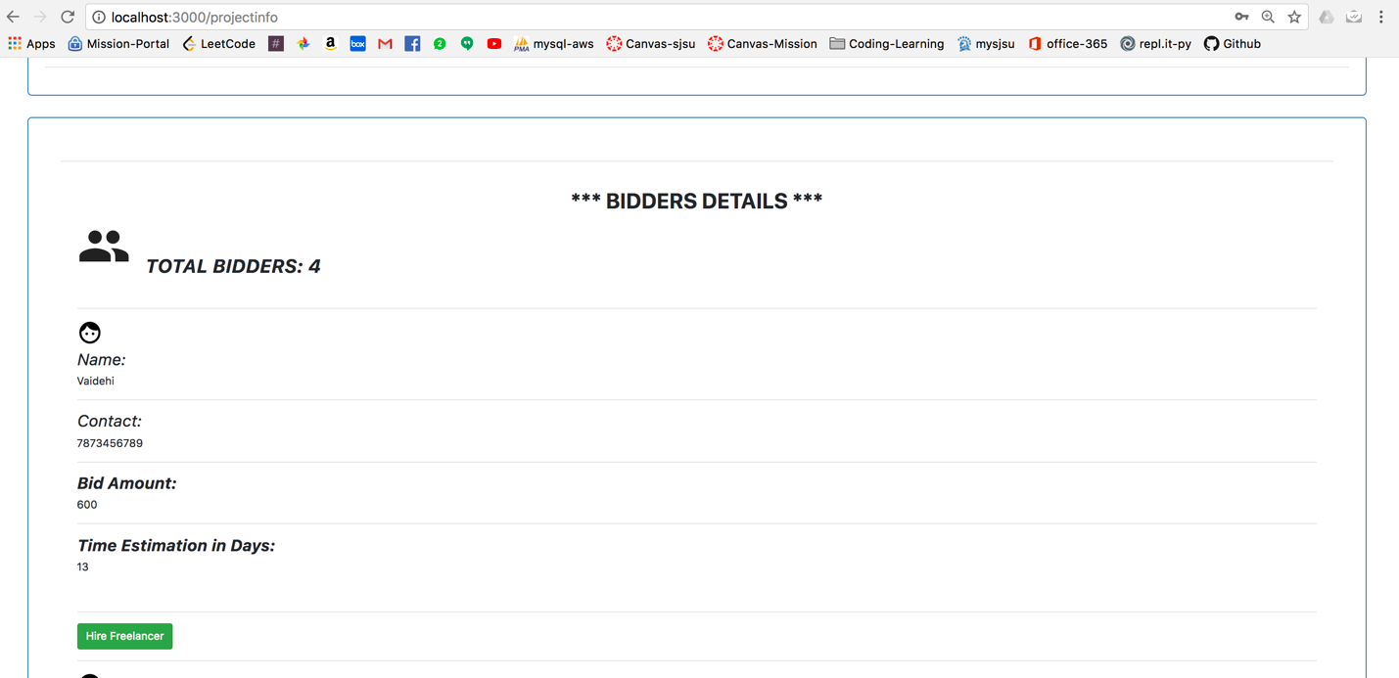

Figure 14: Employer has logged in and can see the total number of bidders and can hire the freelancer by clicking on Hire Freelancer button

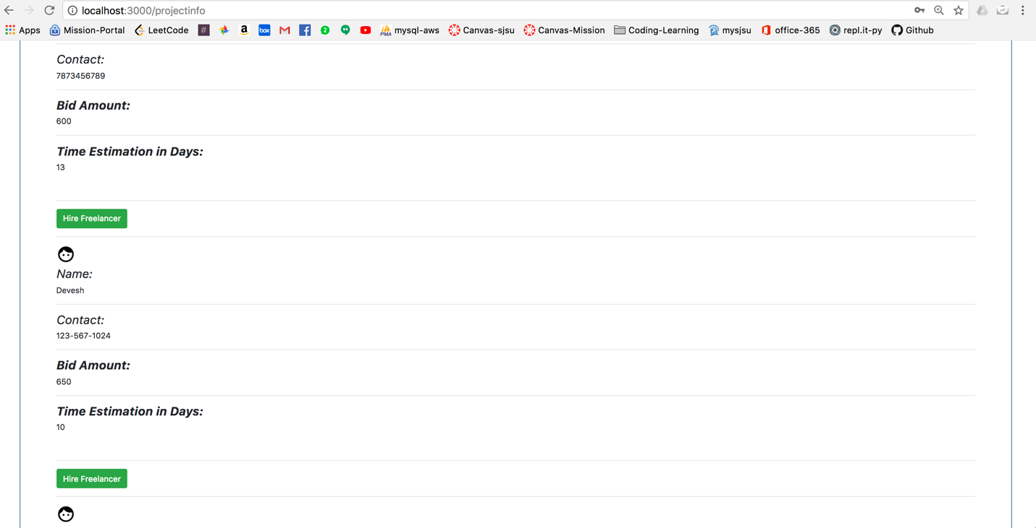

Figure 15: Employer has logged in and can see the total number of bidders and can hire the freelancer by clicking on Hire Freelancer button

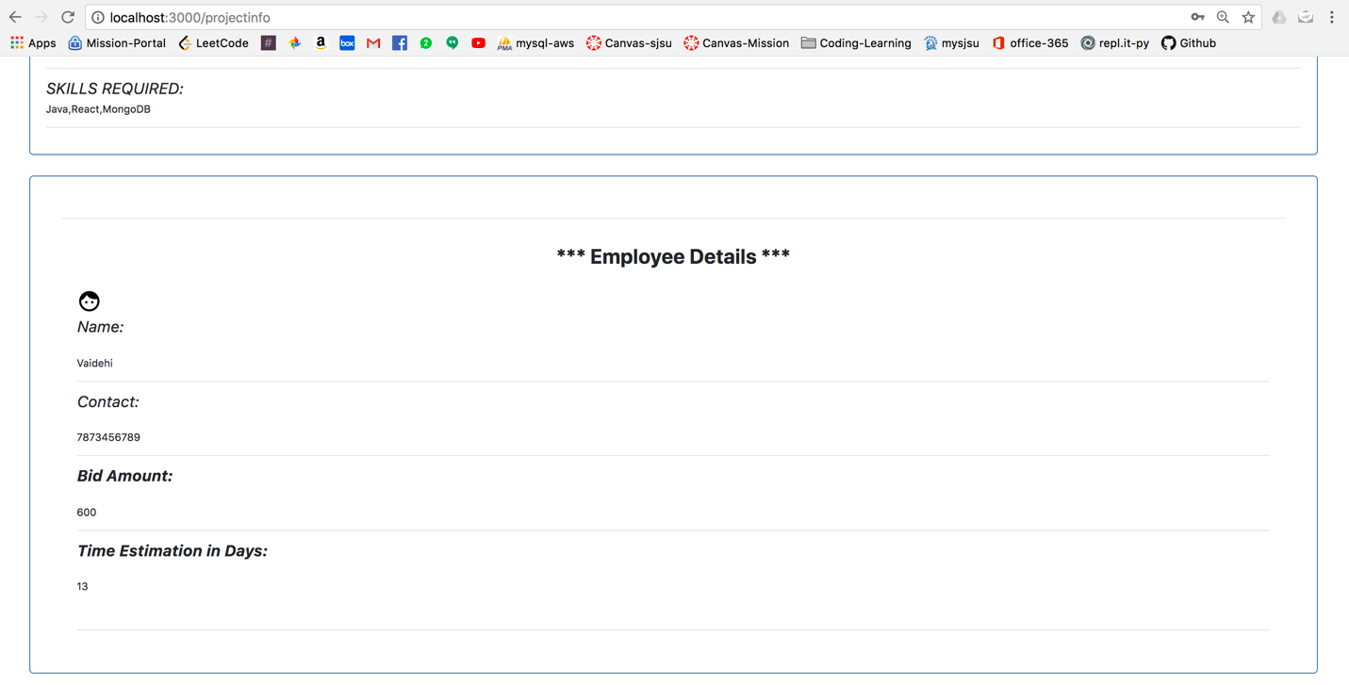

Figure 16: Employee Details....Employer has hired this employee

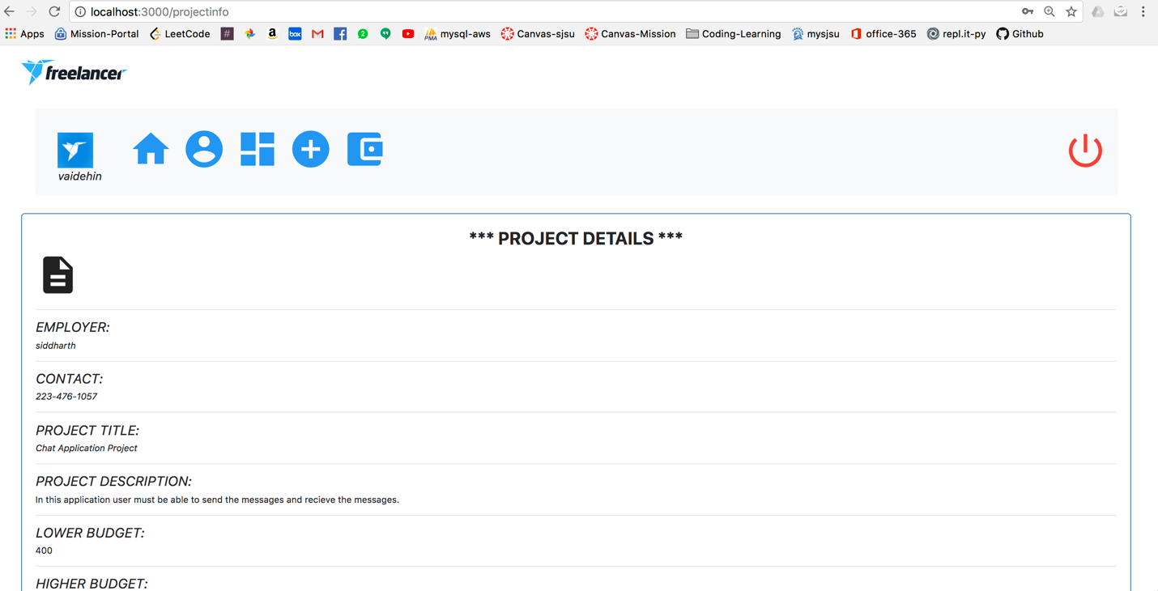

Figure 17: Logged in employee

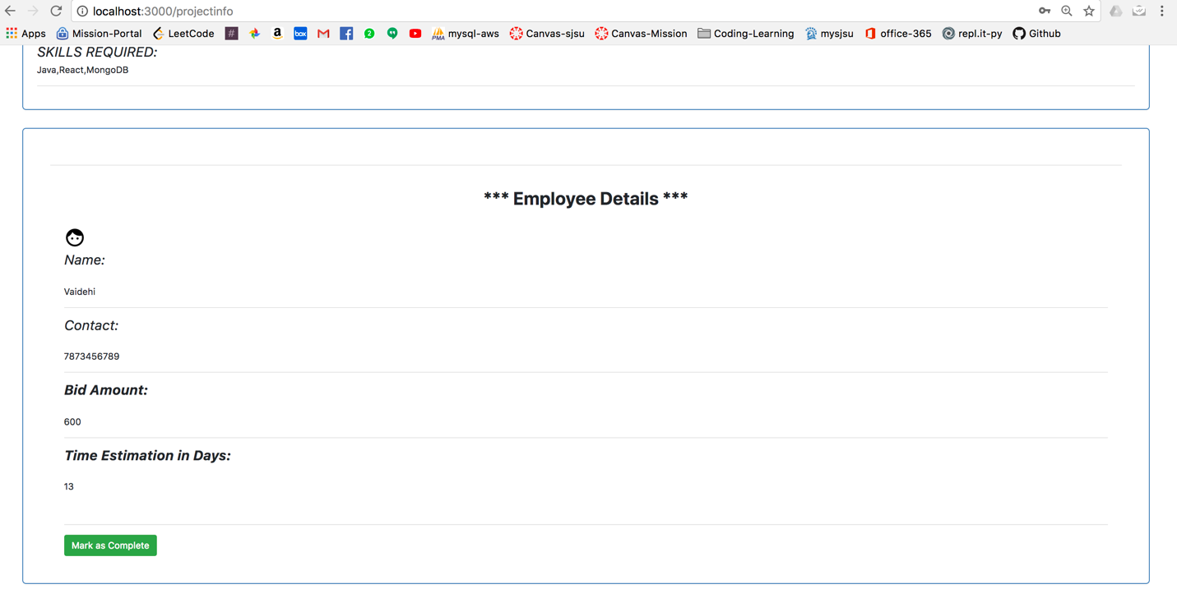

Figure 18: Employee can inform the employer by clicking on this mark as complete button

# Screenshot of Spring boot code:

Spring server up screeshot

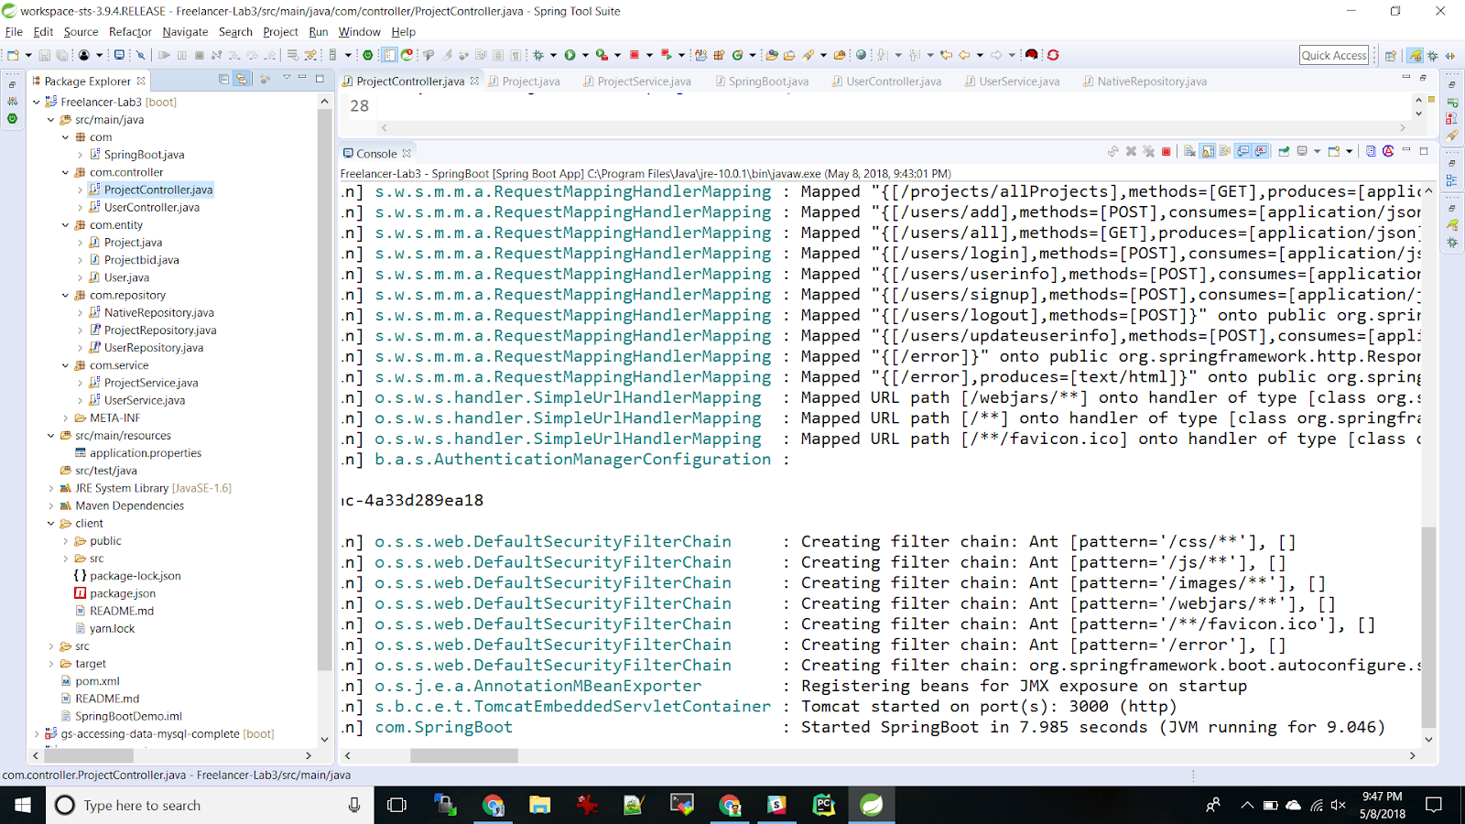

**Controller:**

1. UserController:

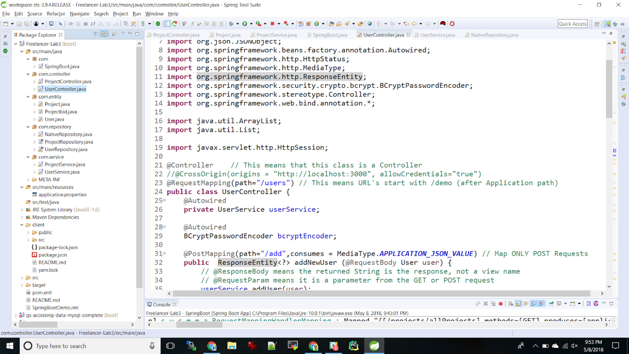

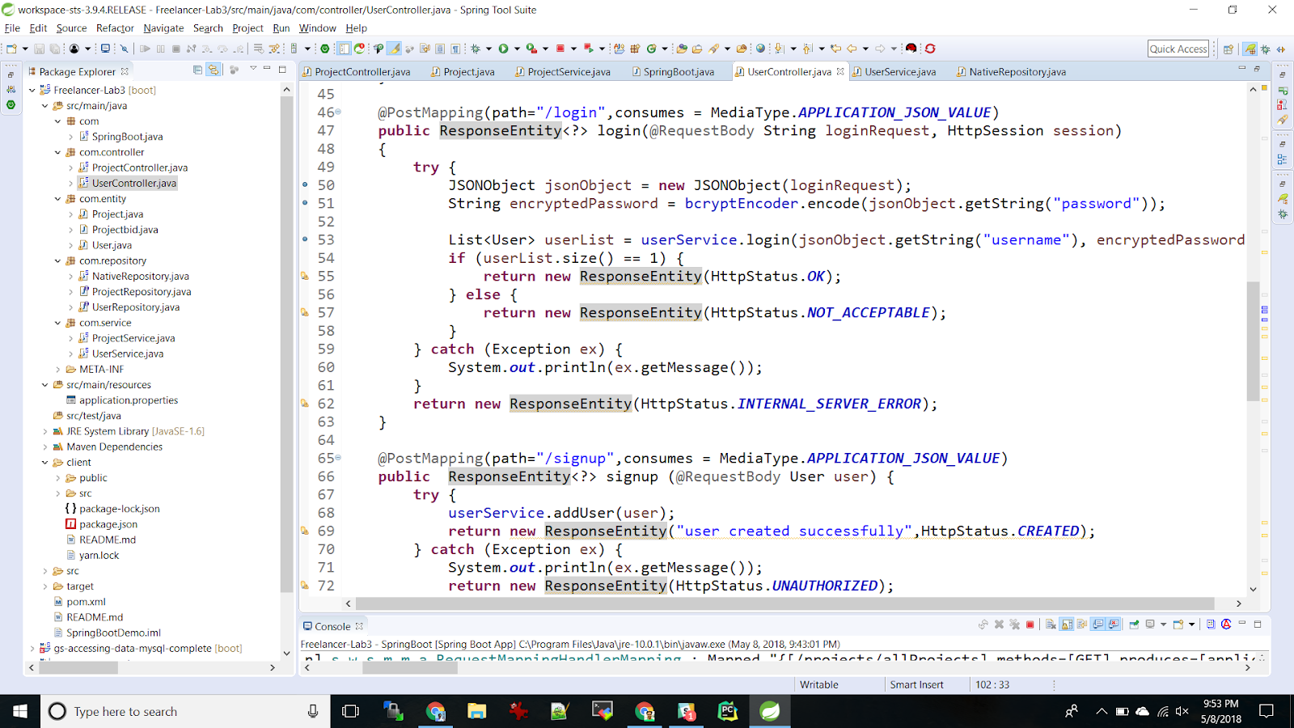

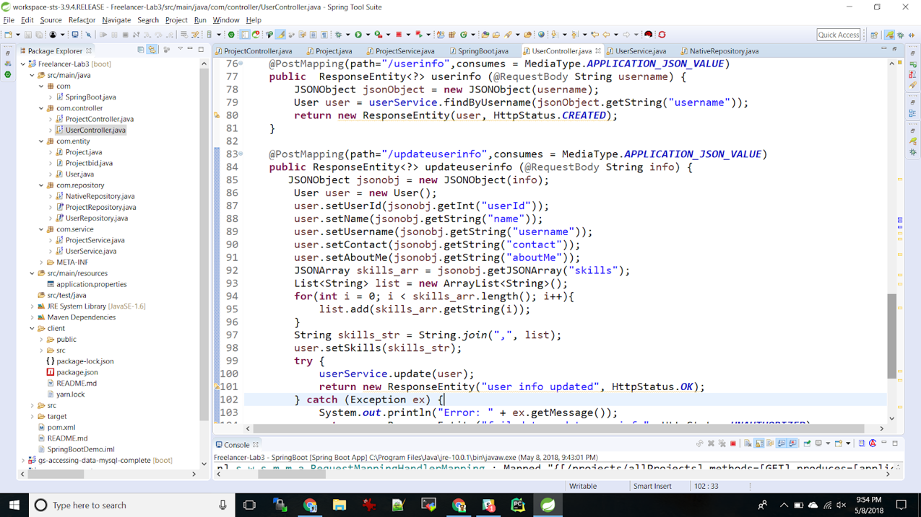

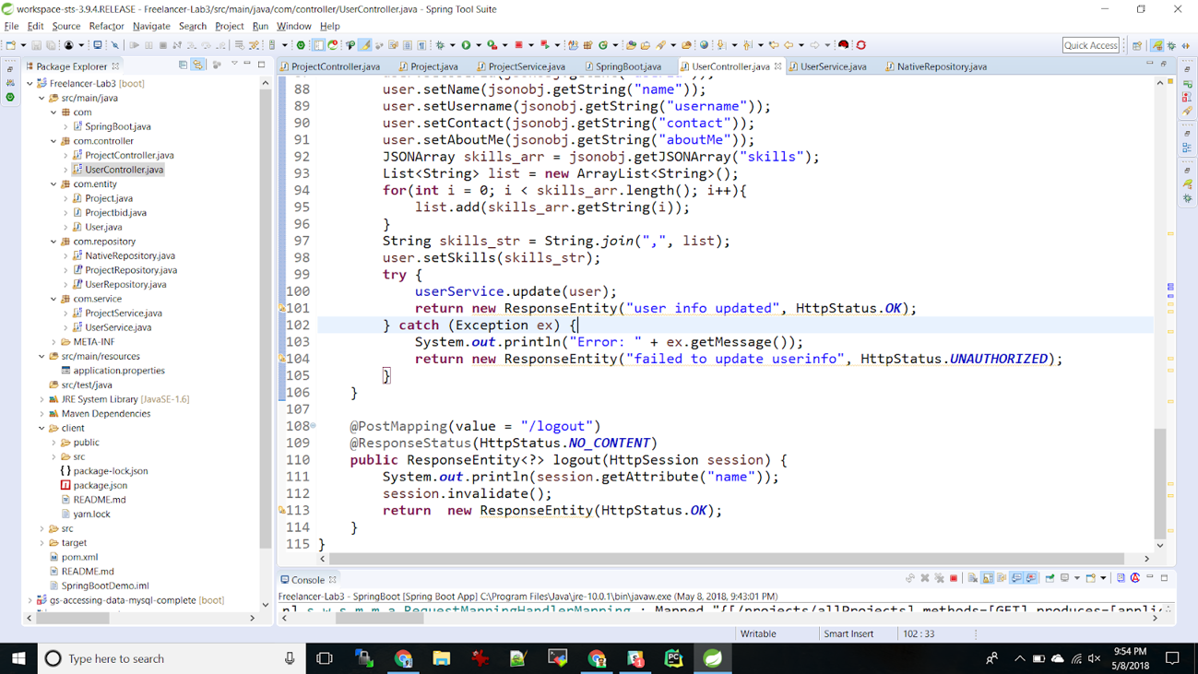

# 

1. ProjectContorller:

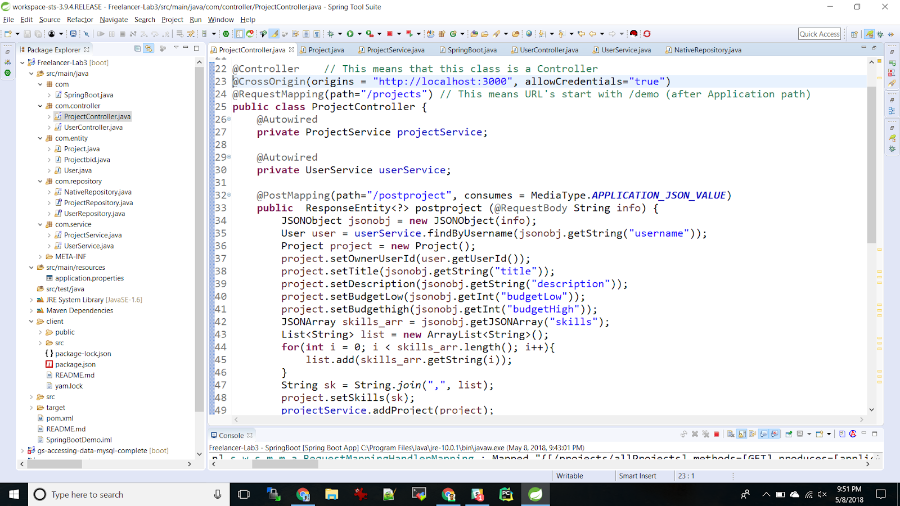

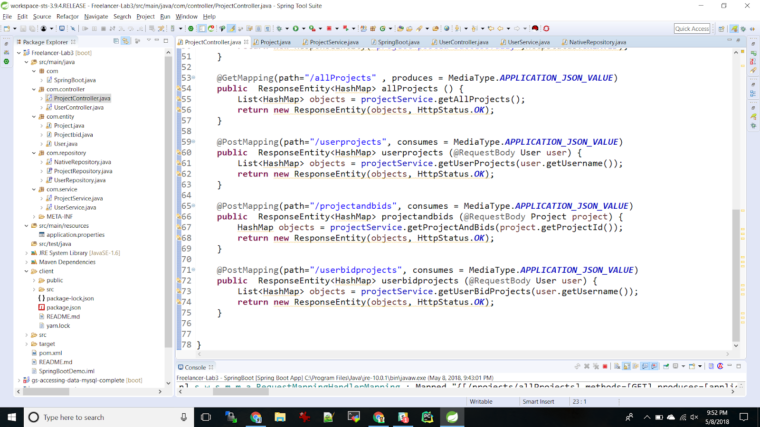

Entity Class Mapped with DB

1. Project.java:

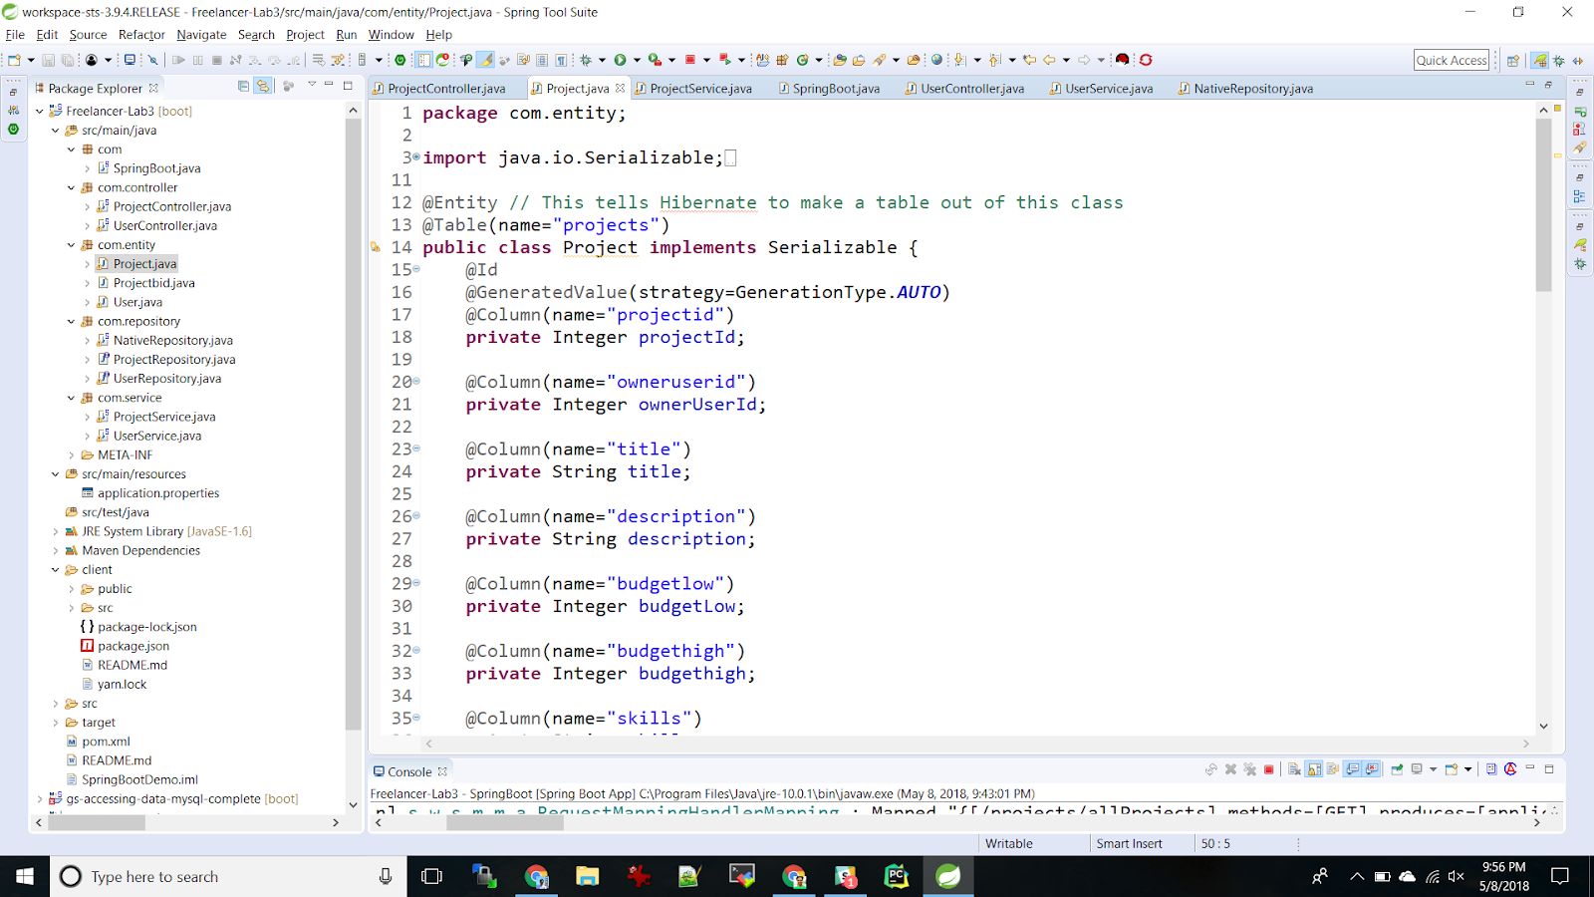

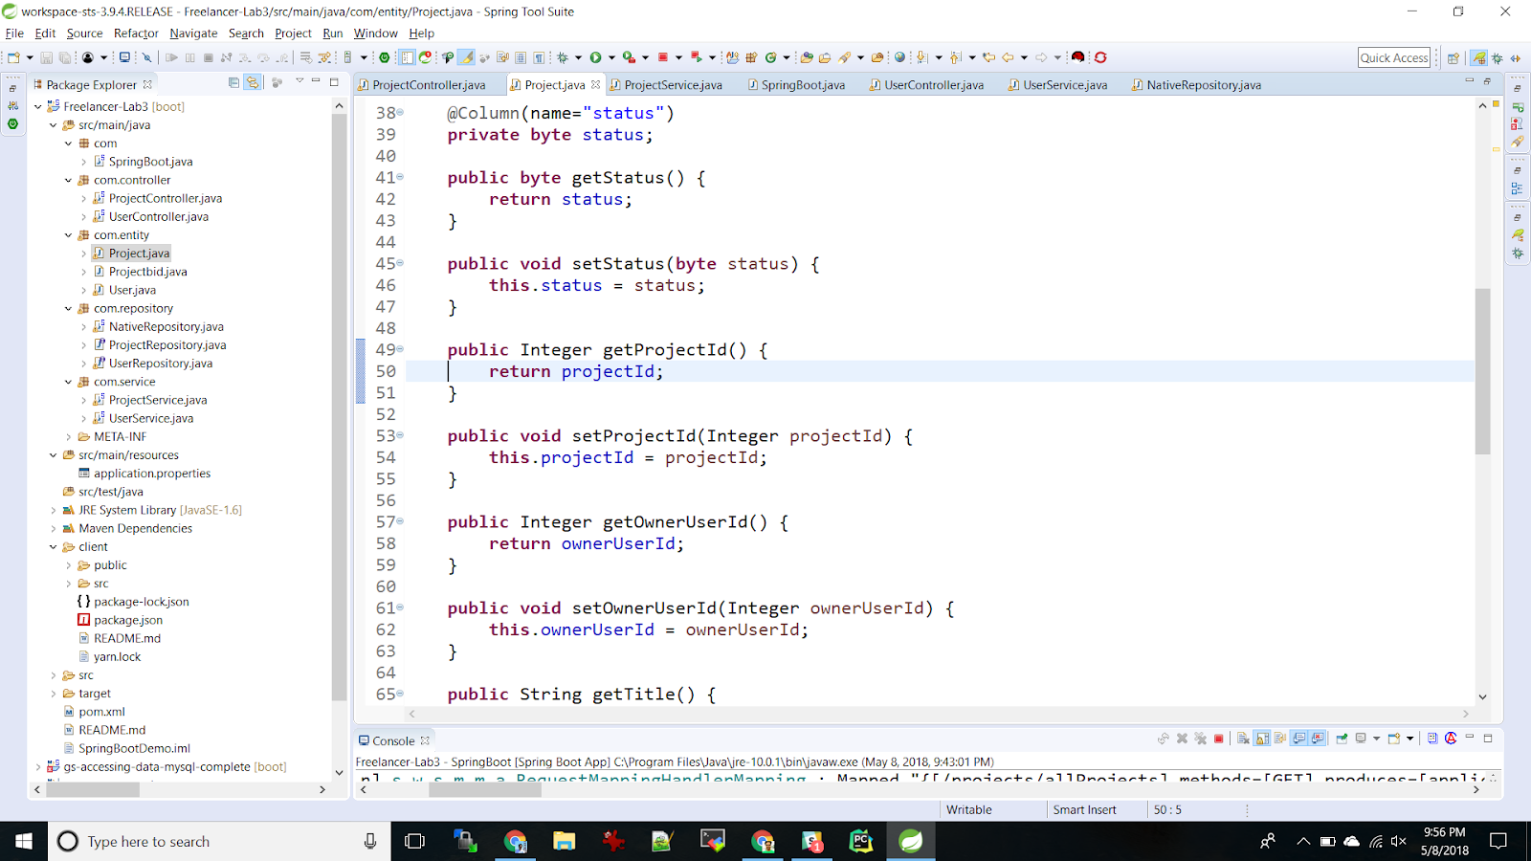

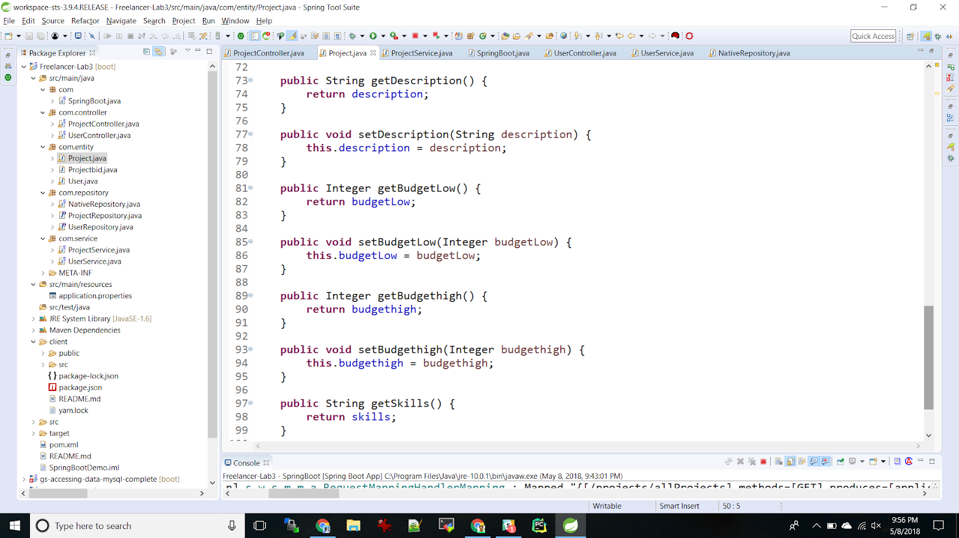

1. User.java:

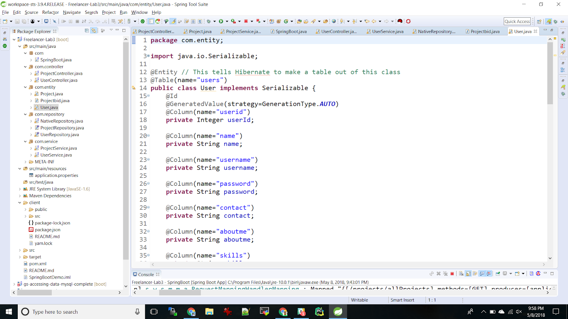

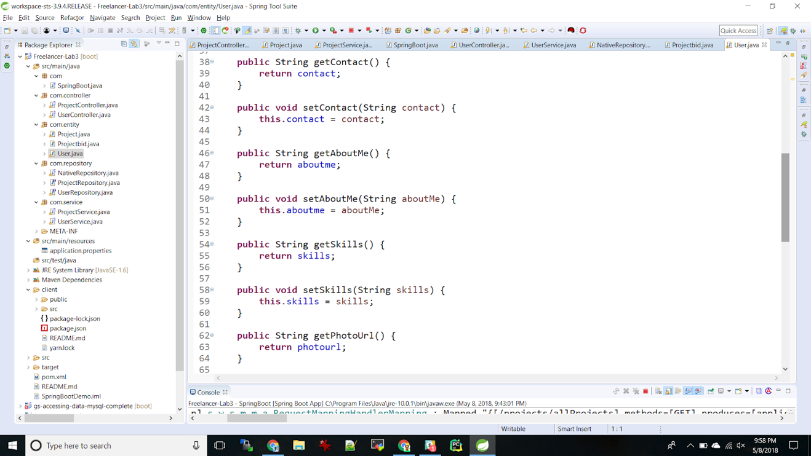

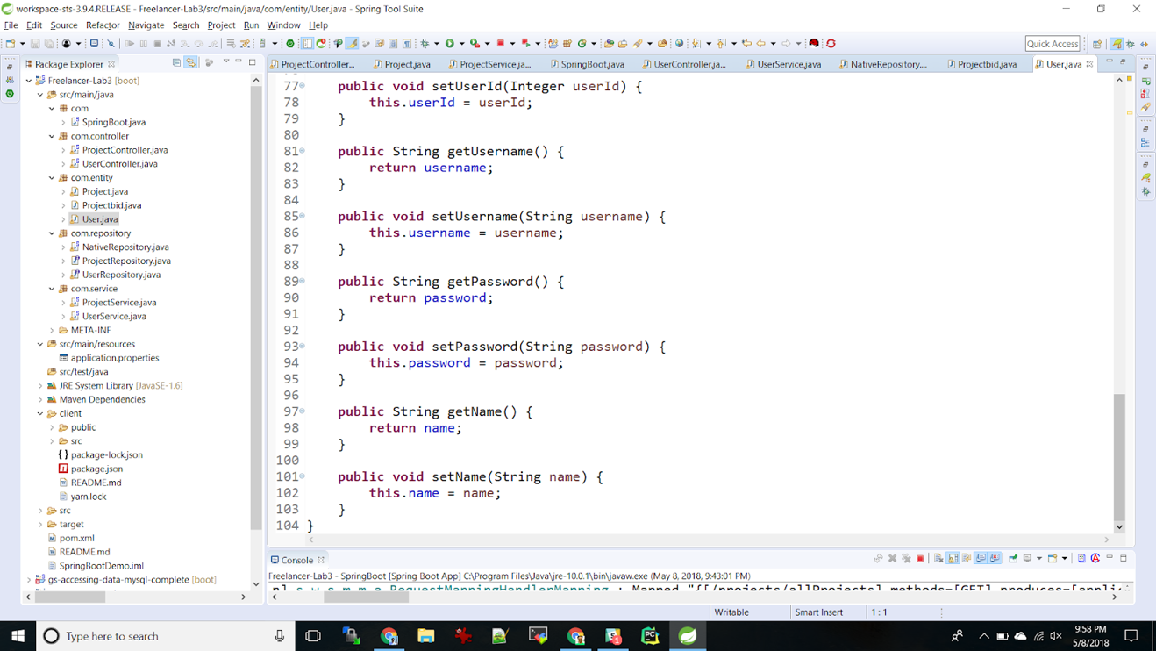

**Repository ScreenShots:**

1. **Native Repository: This repository is created for the complex queries.**

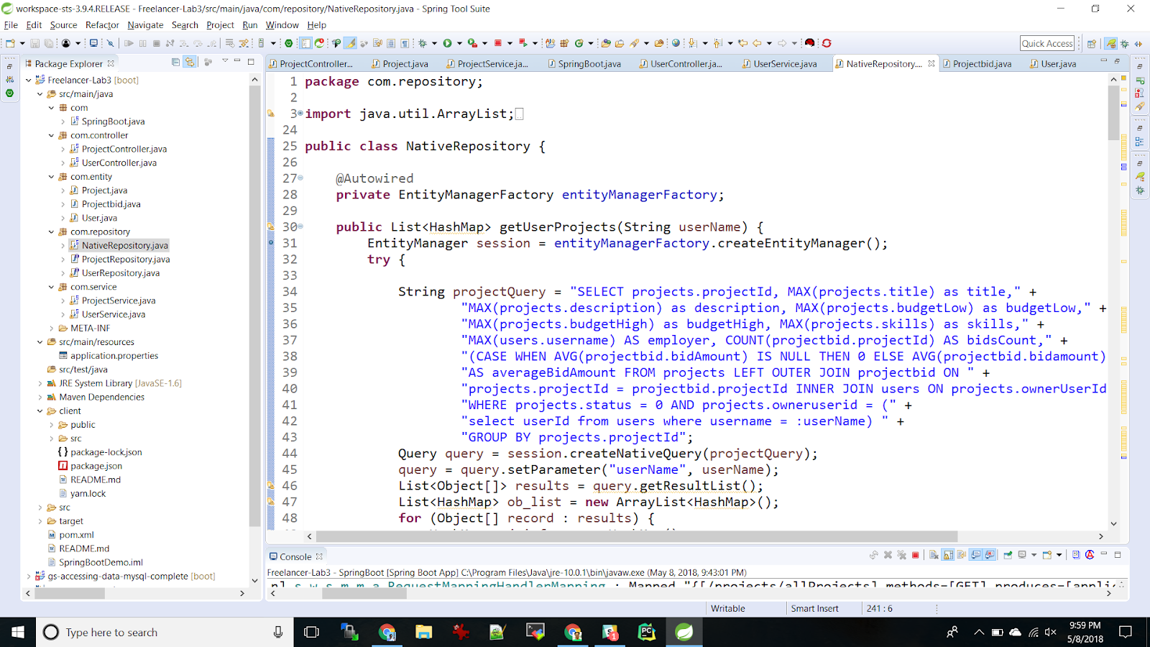

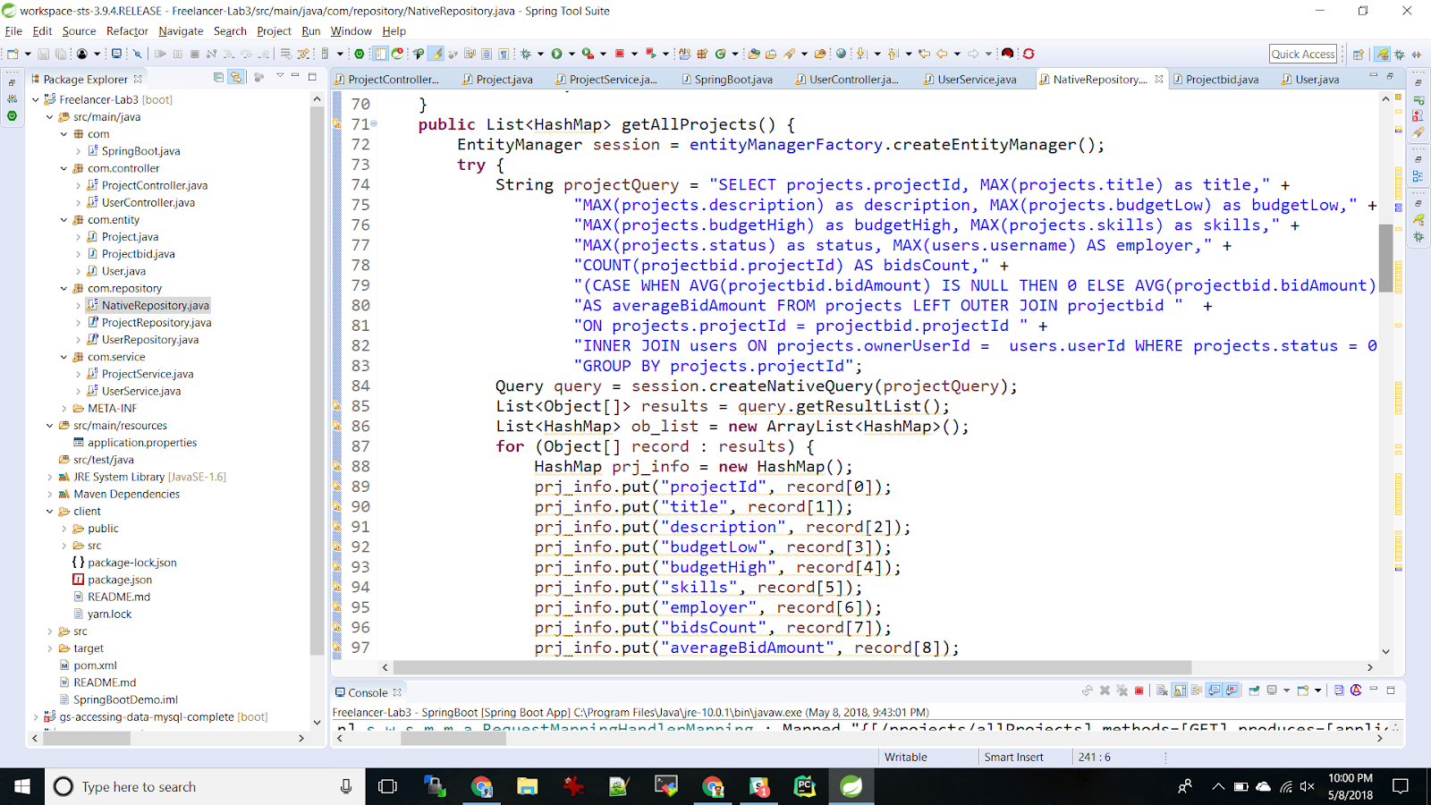

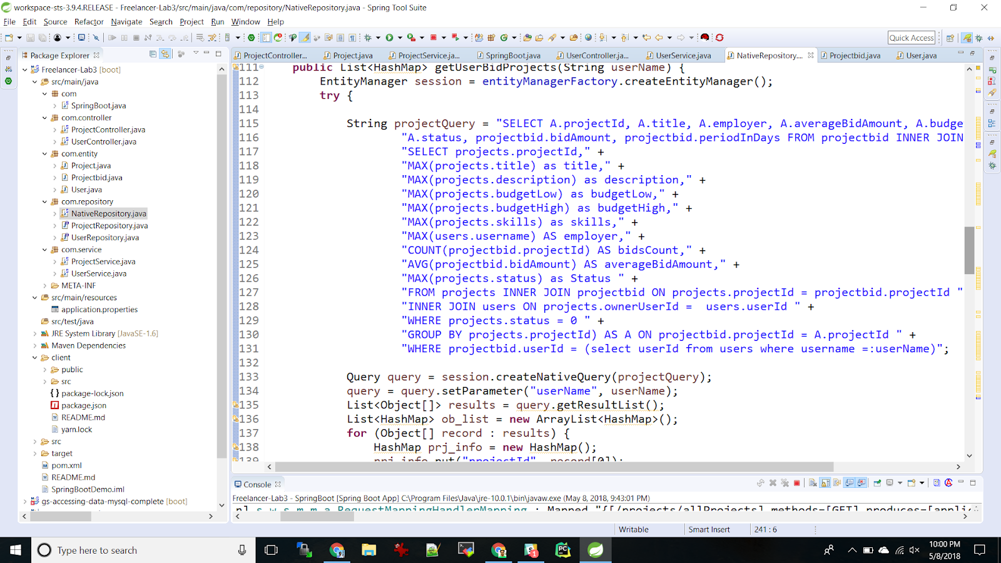

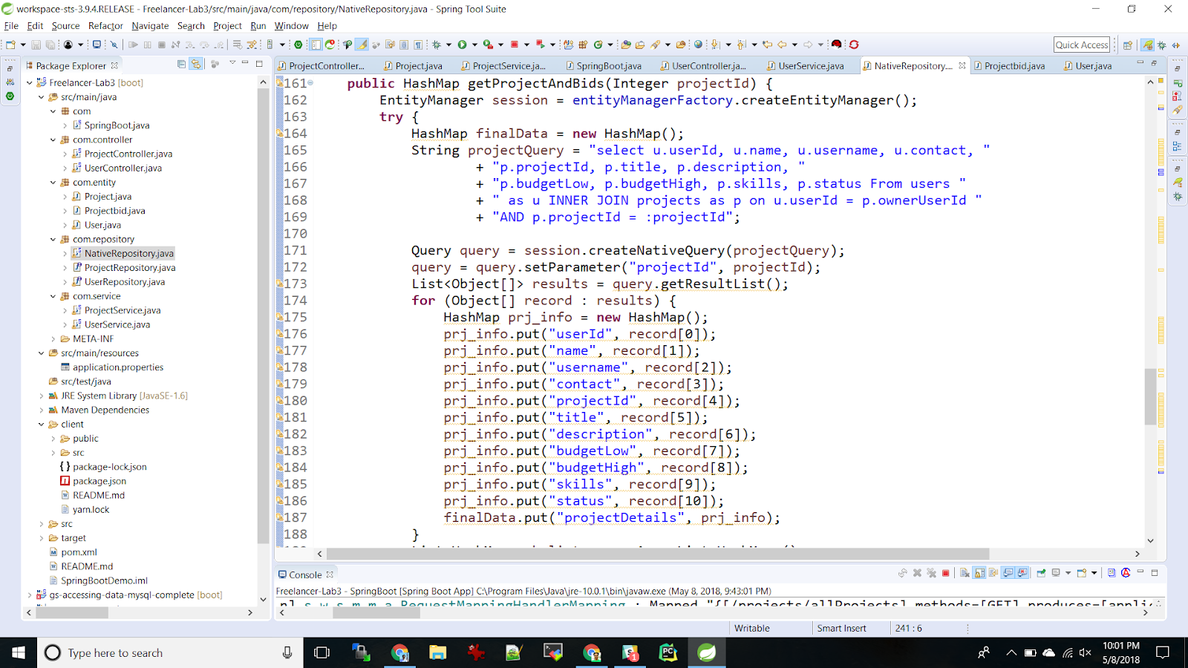

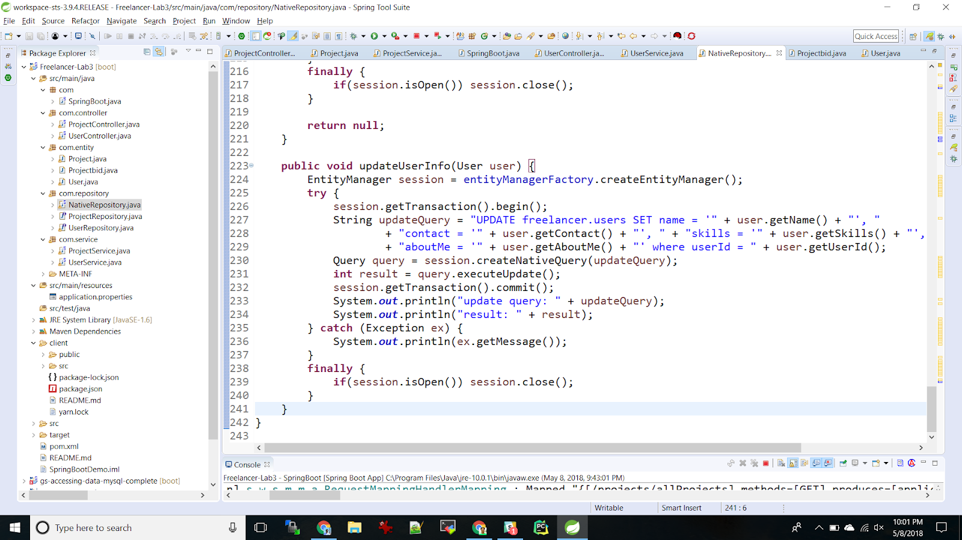

1. **UserRepository:**

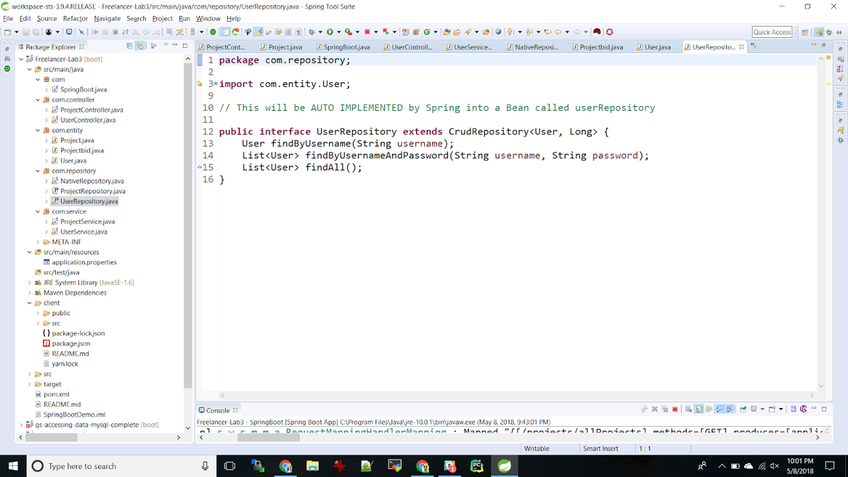

1. ProjectRepository:

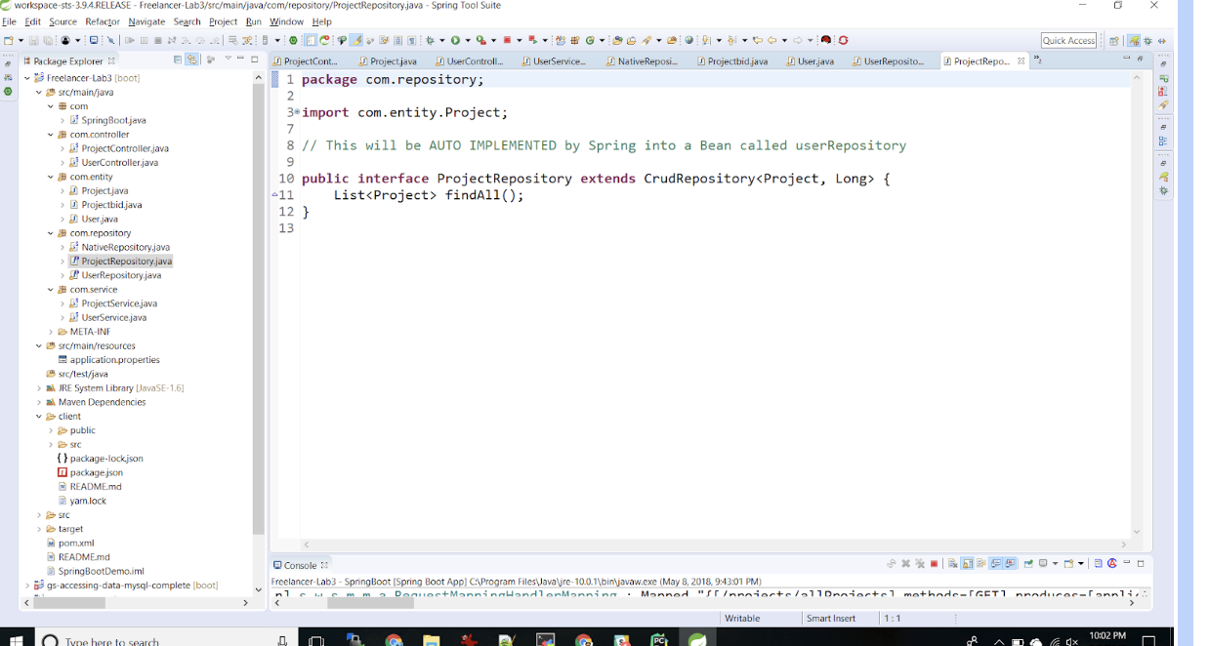

## Testing:

### JMeter:

#### Without Connection Pooling:

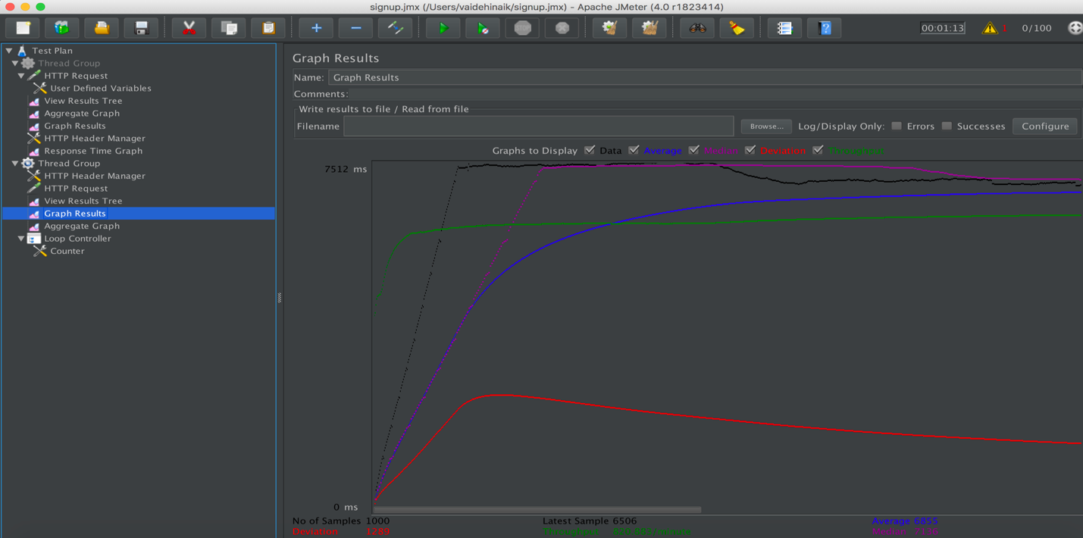

Figure 19: 100 users

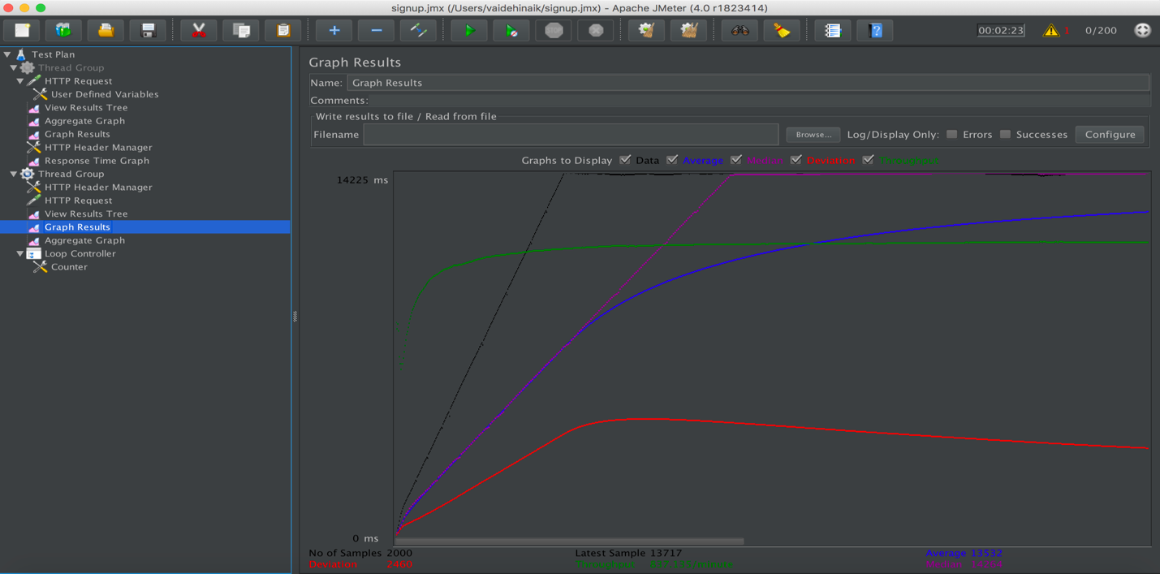

Figure 20: 200 users

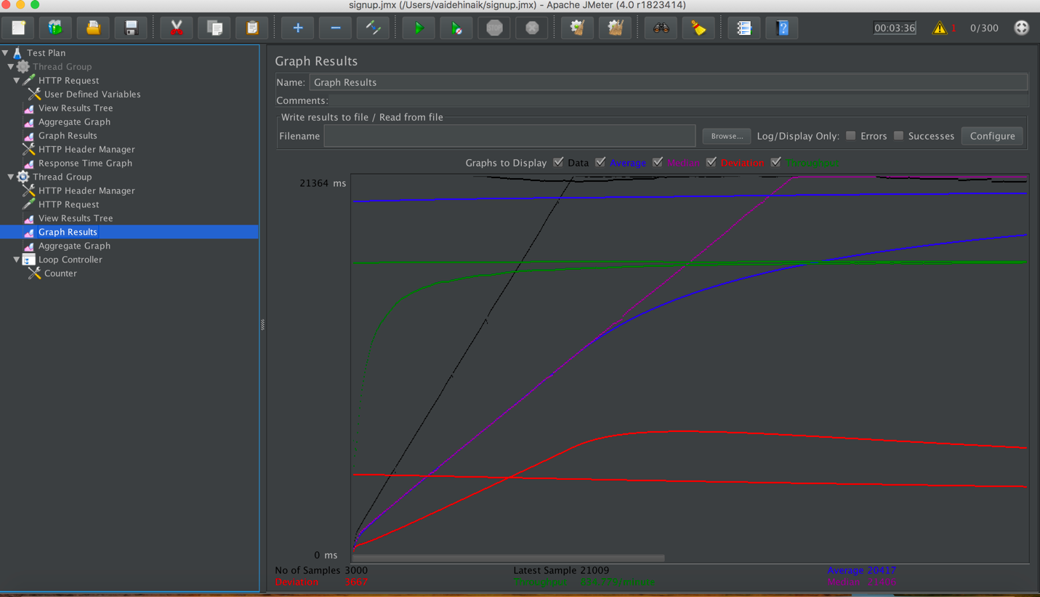

Figure 21: 300 users

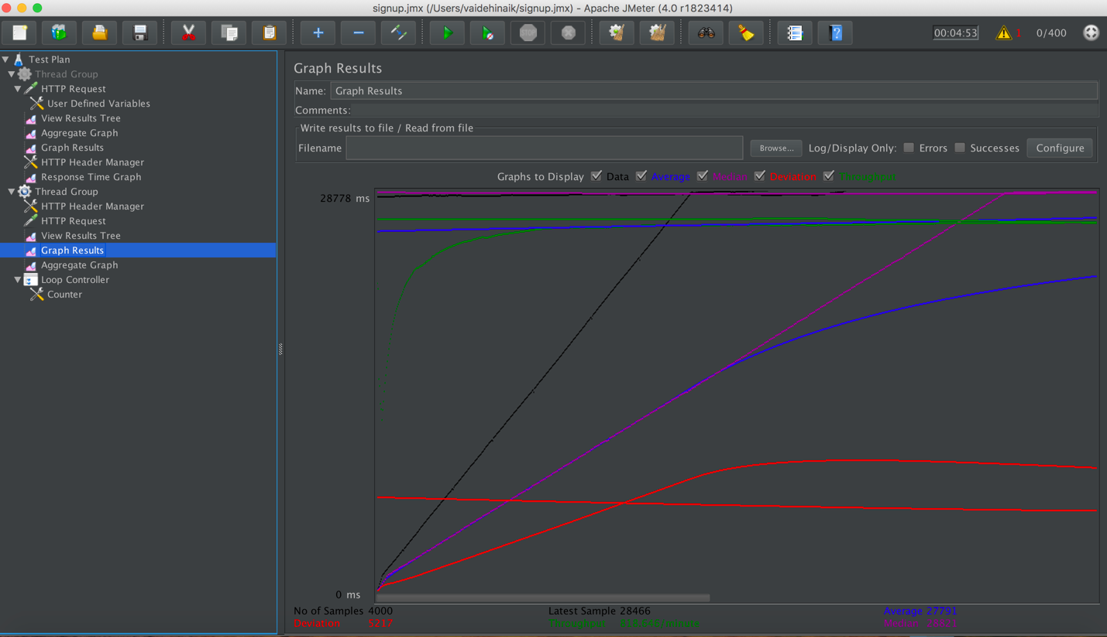

Figure 22: 400 users

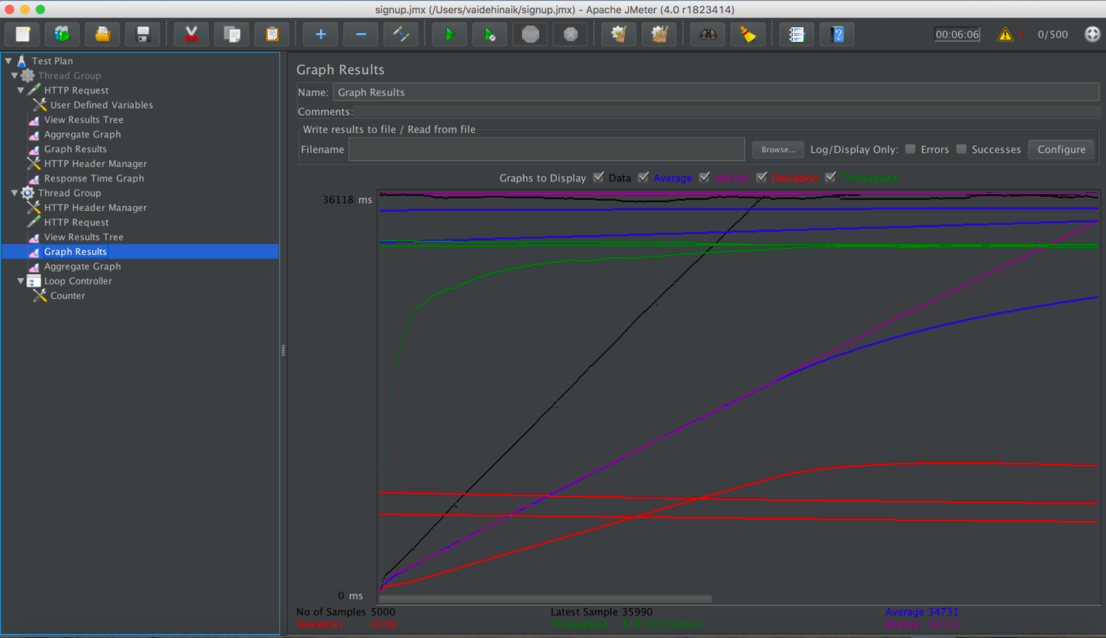

Figure 23: 500 users

#### With Connection Pooling:

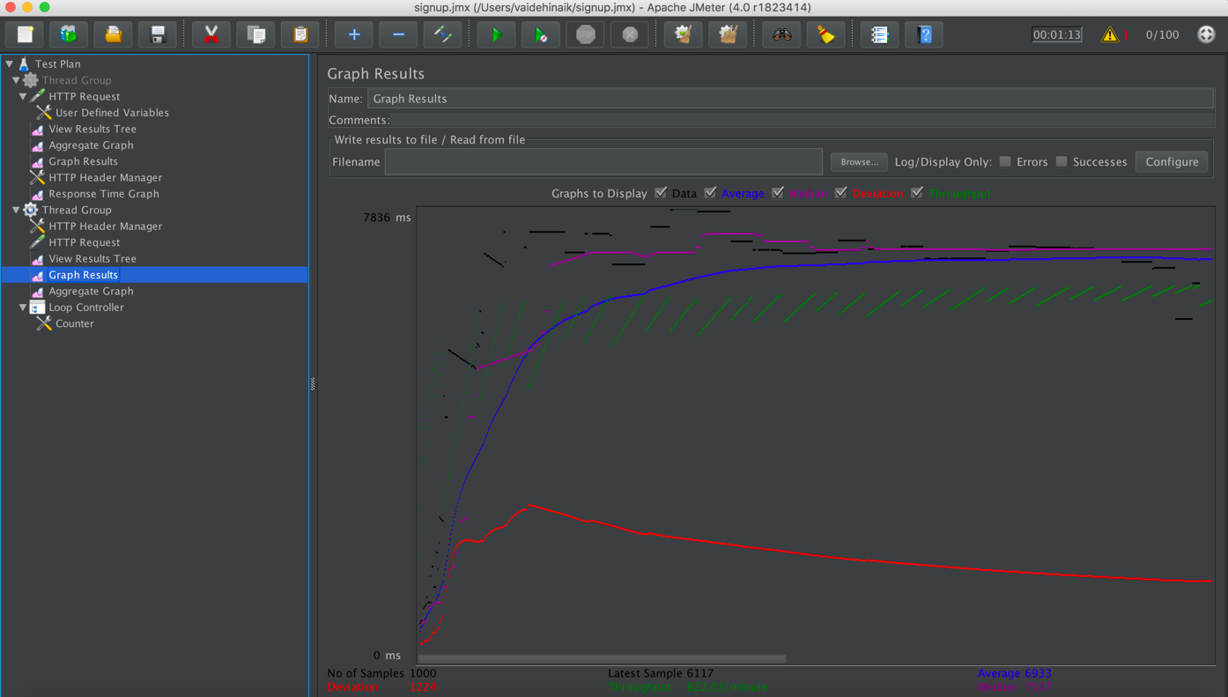

Figure 24: 100 users

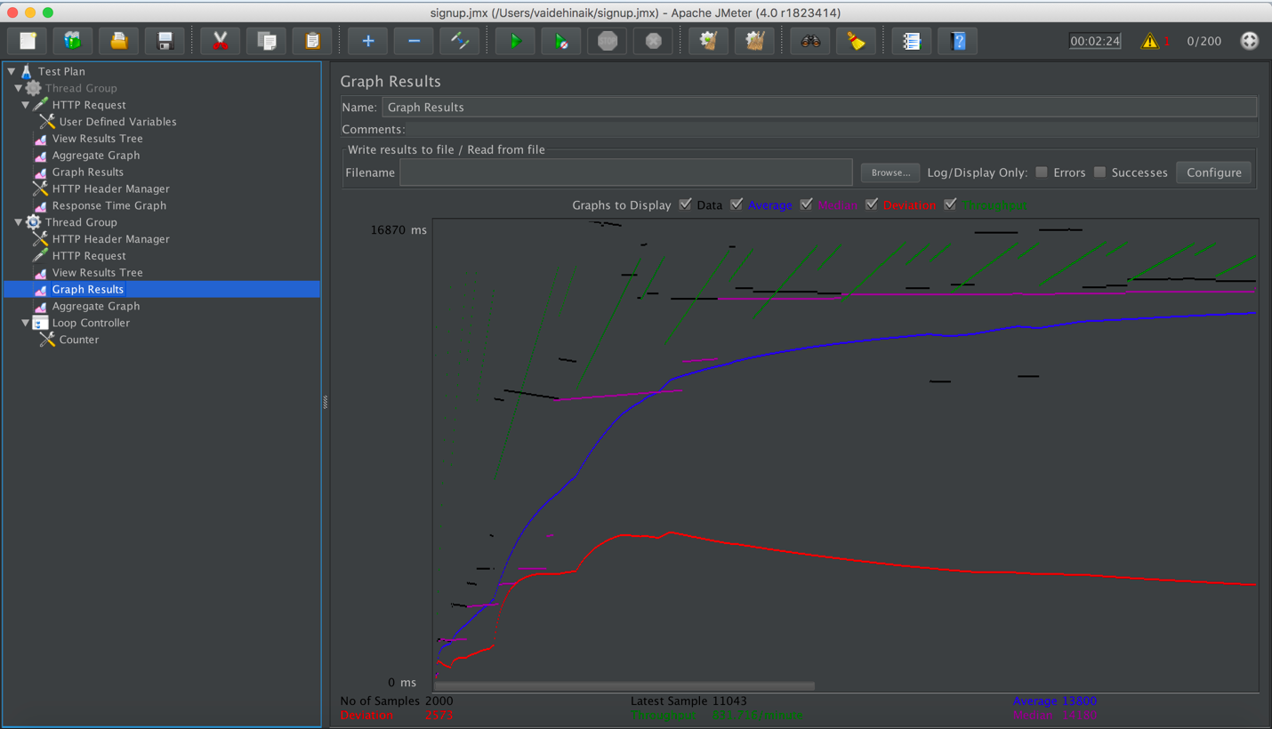

Figure 25: 200 users

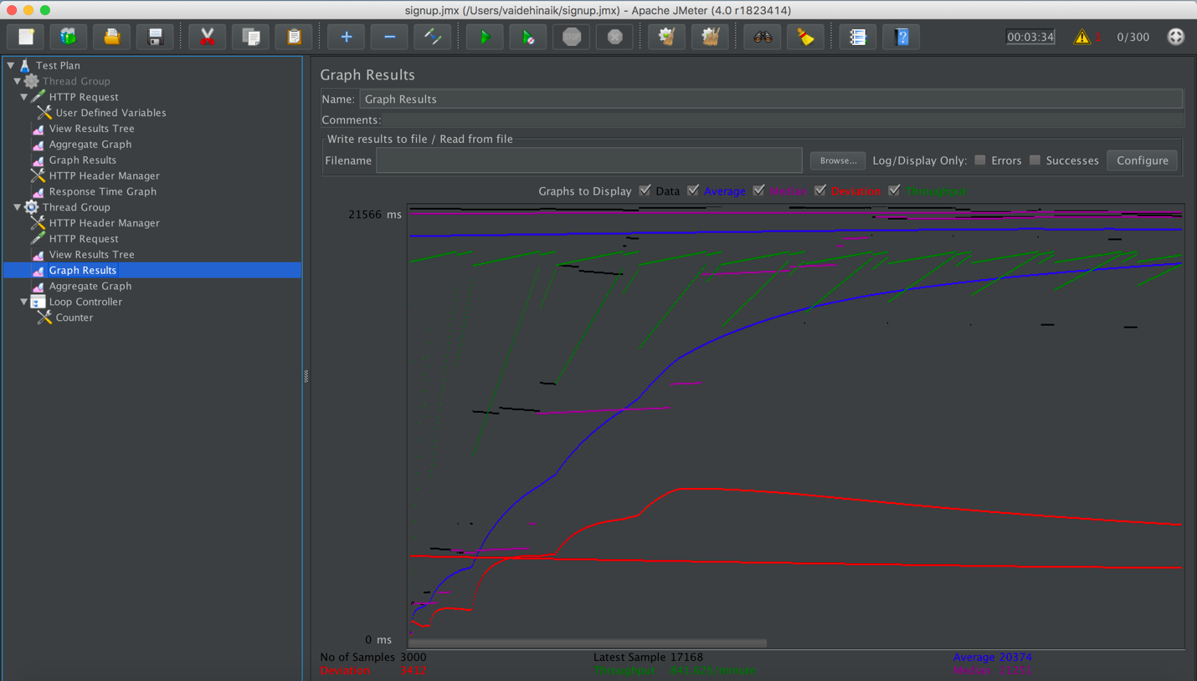

Figure 26: 300 users

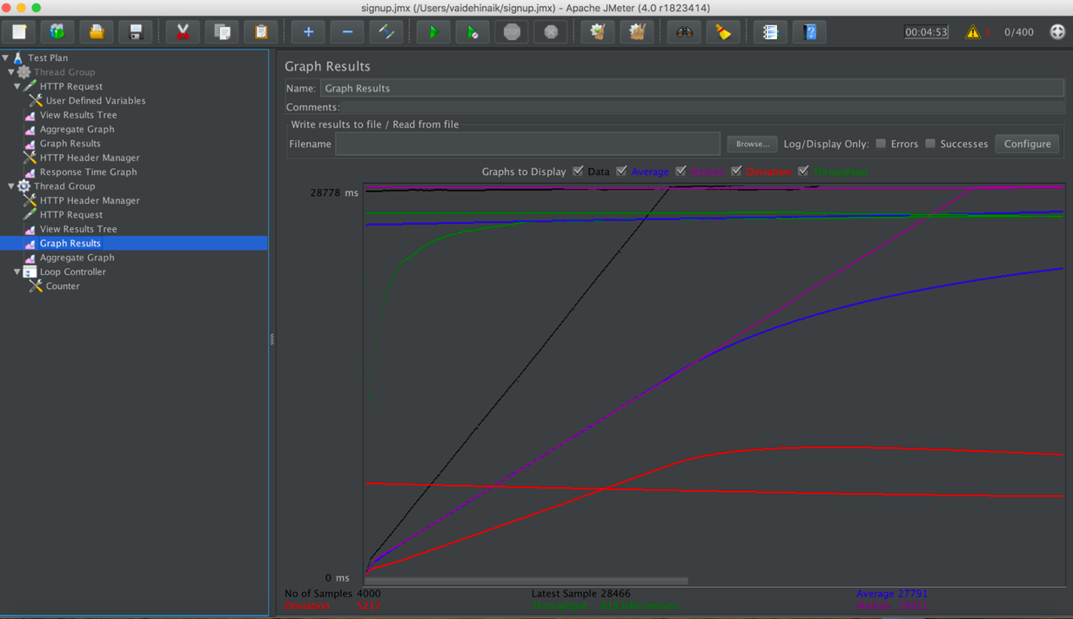

Figure 27: 400 users



Figure 28: 500 users

### Junit:

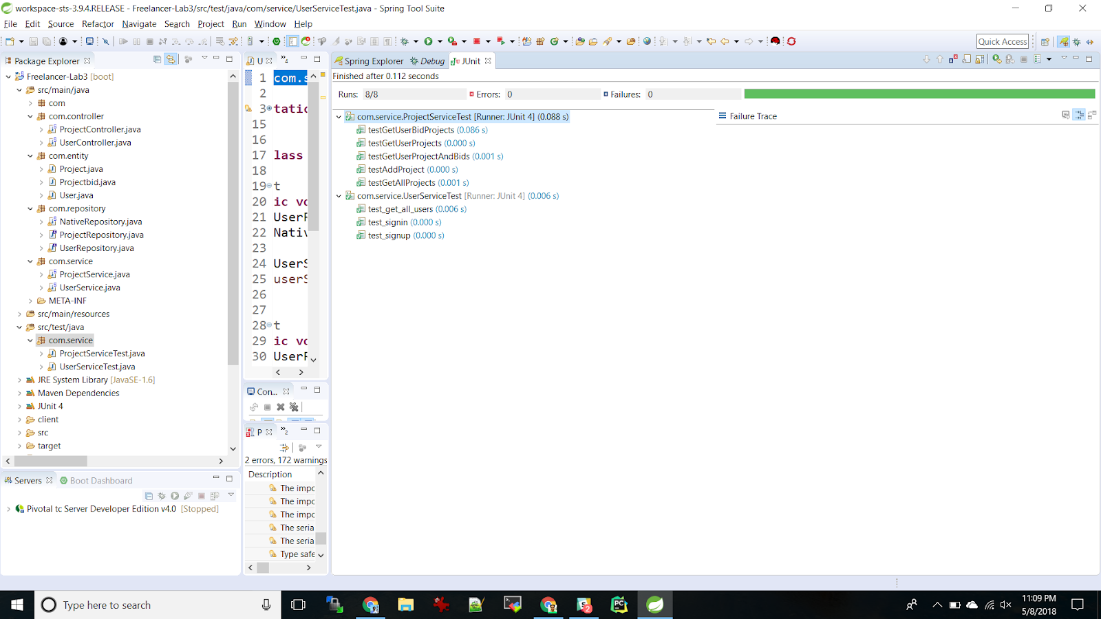

Figure 29: Junit test results

### Postman:

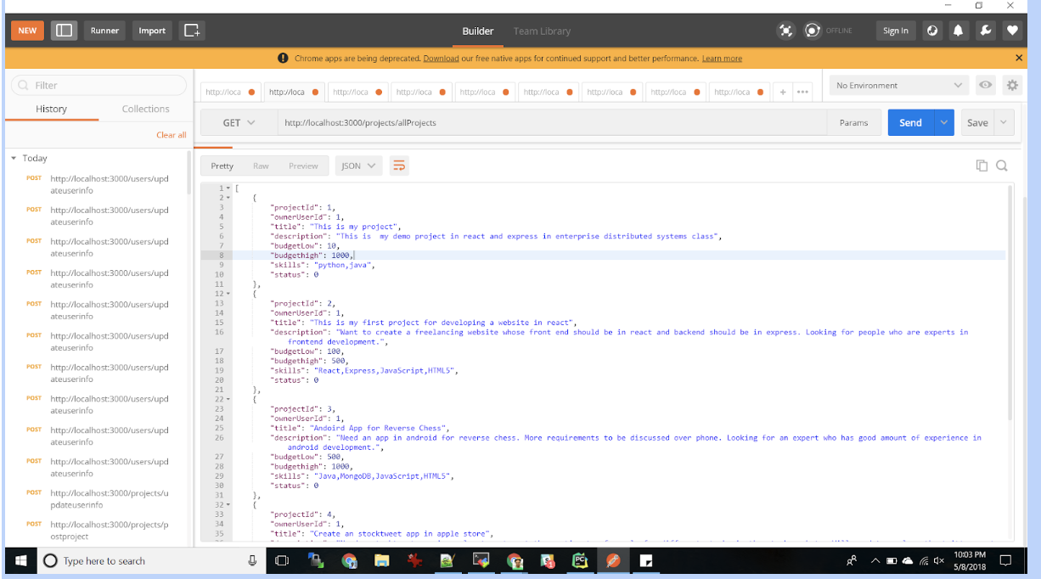

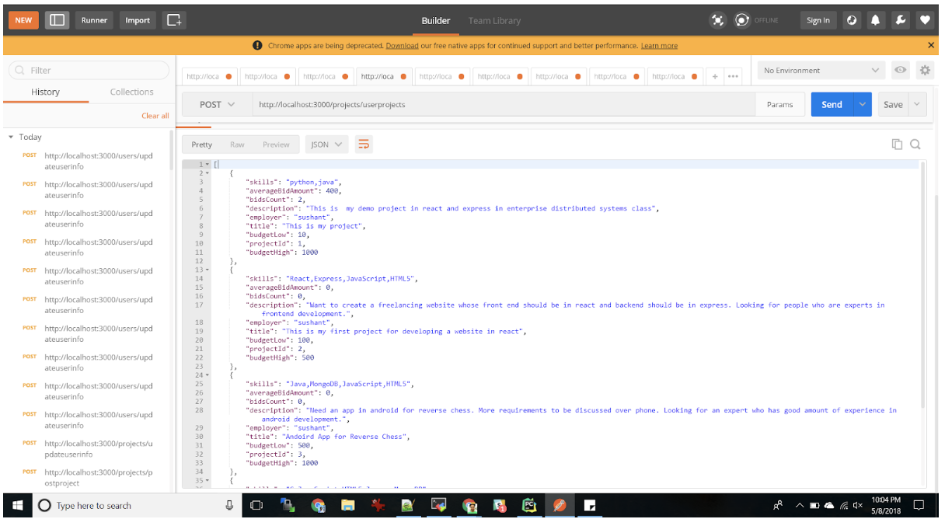

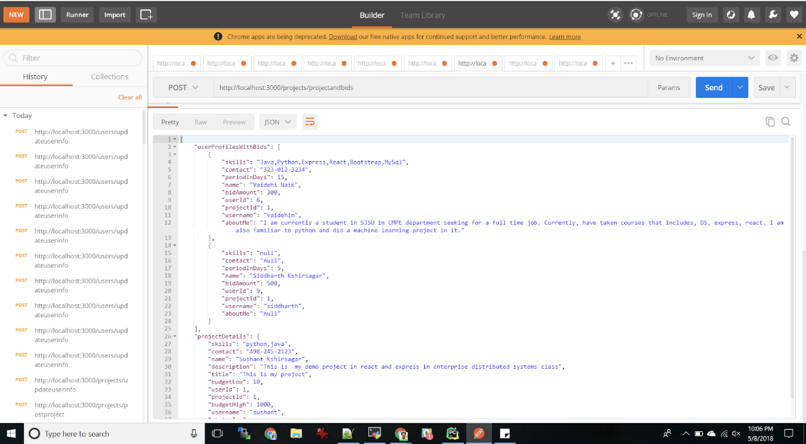

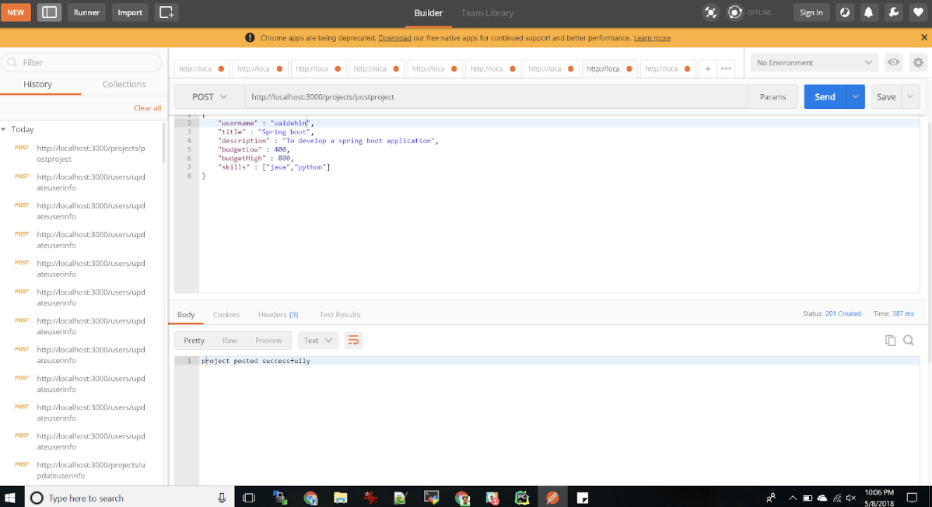

# GitHub:

## Github Link:

<https://github.com/vaidehinaik/Freelancer_SpringBoot.git>